Tab 1

LAB Overview

Active Directory & Windows Networking Lab Summary
This lab demonstrates the setup and management of an Active Directory environment in a virtualized Windows network. It includes installing and configuring a Domain Controller with DHCP, DNS, and Organizational Units, creating users with PowerShell automation scripts, and joining a client VM to the domain. The lab also covers internal networking, NAT routing, and troubleshooting connectivity issues, showing practical problem solving and system administration skills. Completing this lab reinforces my practical skills in managing Active Directory, configuring clients, and troubleshooting network connectivity

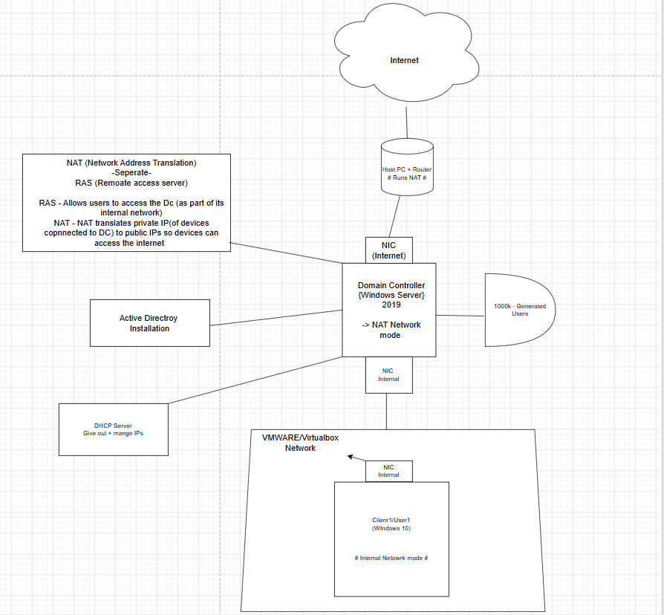

Table of Contents:
Check Document Tabs

NIC Creation - Pages 4 - 5
Error: Disk Issue - Pages 6 - 10
IP Address Configuration - Pages 11 - 14
Renaming Computer - Pages 15 -16
Active Directory Installation and Domain Creation - Pages 17 - 25
Organizational Unit and Domain Account Creation - Pages 26 - 31
Remote Access and NAT Installation - Pages 32 - 43
DHCP Configurations - Pages 44 - 50
Internet Browsing on Domain Controller - Pages 51 - 55
Powershell Scripting - Pages 56 - 63
Windows 10 Client Creation VM - Pages 64 - 83
Integrating Client1 to Domain Controller - Pages 85 - 93

NIC Creation

When i was creating domain controller, I wanted 2 NIC
> One dedicated for internet: So it can access the real internet from your VM
> One dedicated for internal vm network:

This is for the lab network only
VMs use this to talk to each other:
- Domain Controller (DC)
- Windows 10 client

Connect to house internet

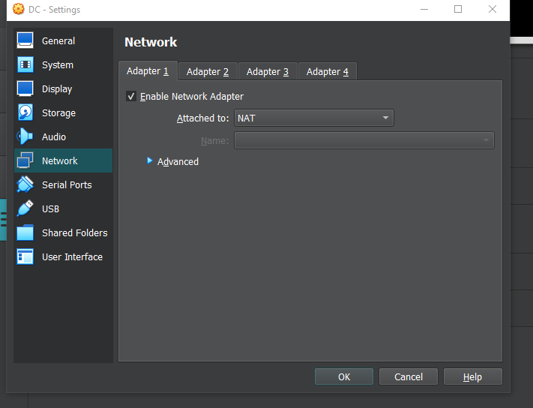

Internet network

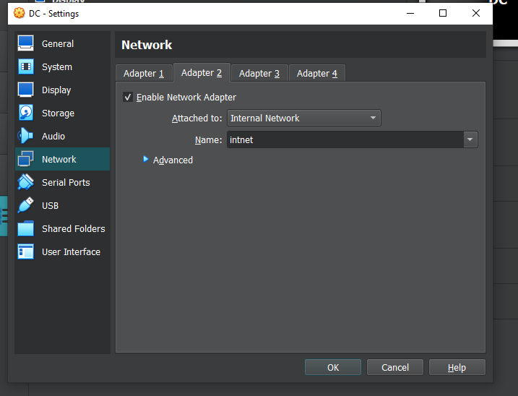

Error: Disk Issue
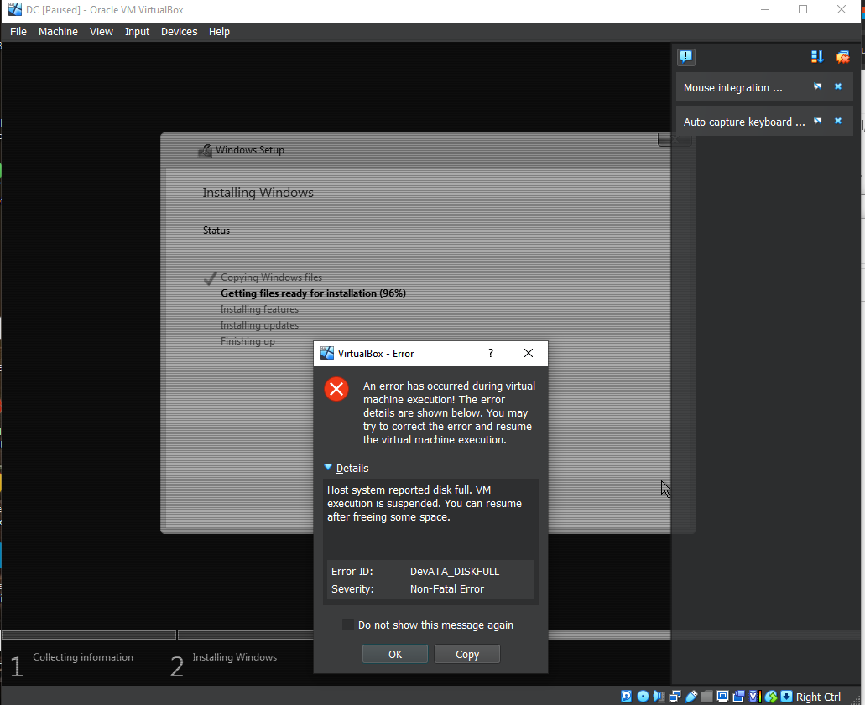

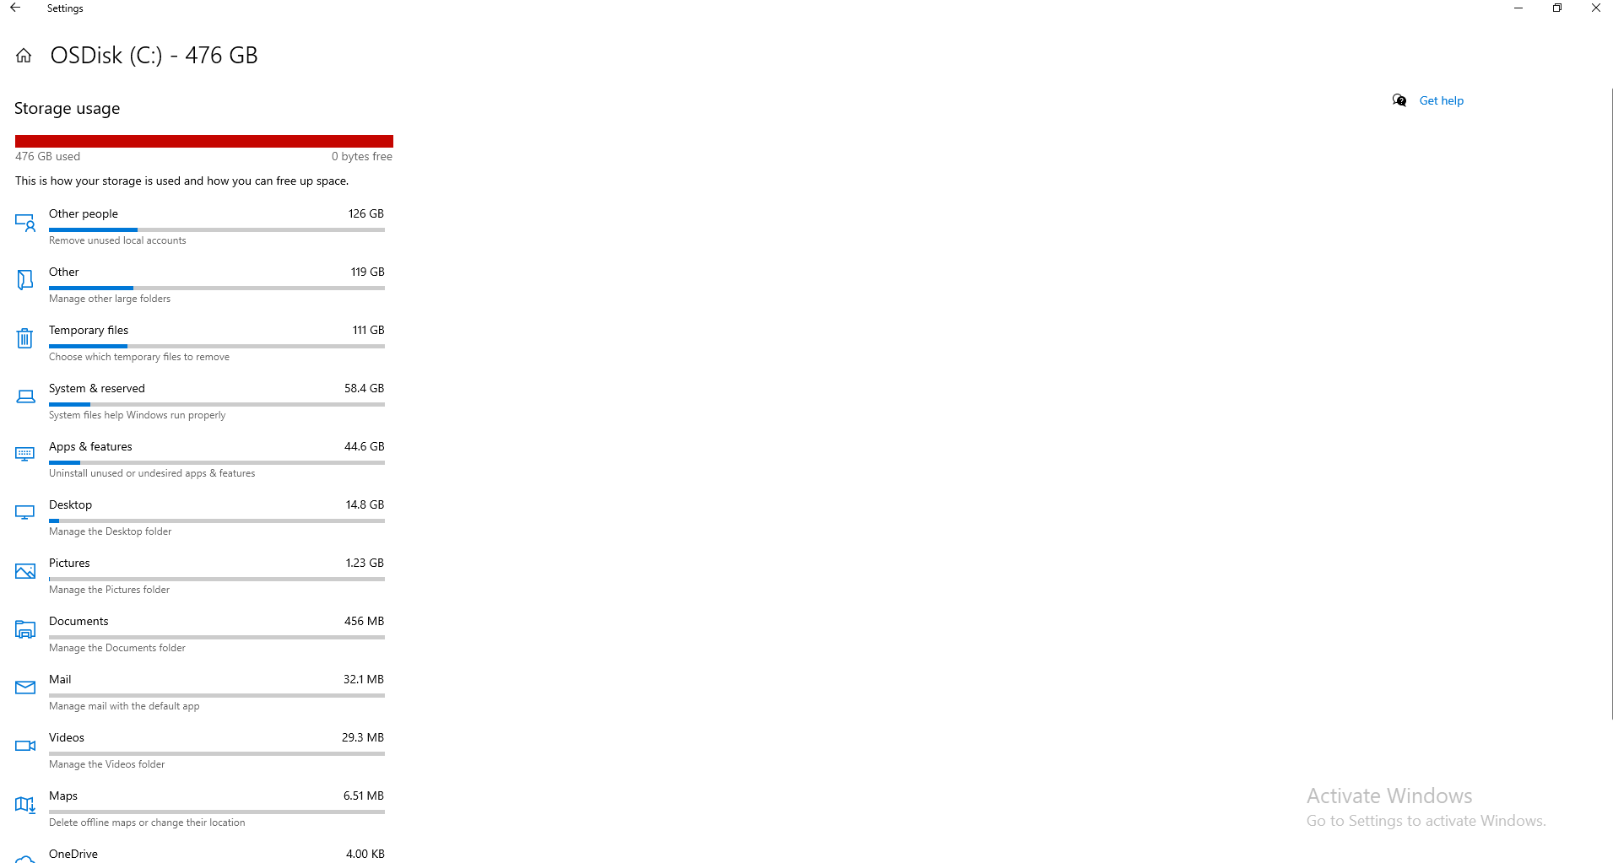

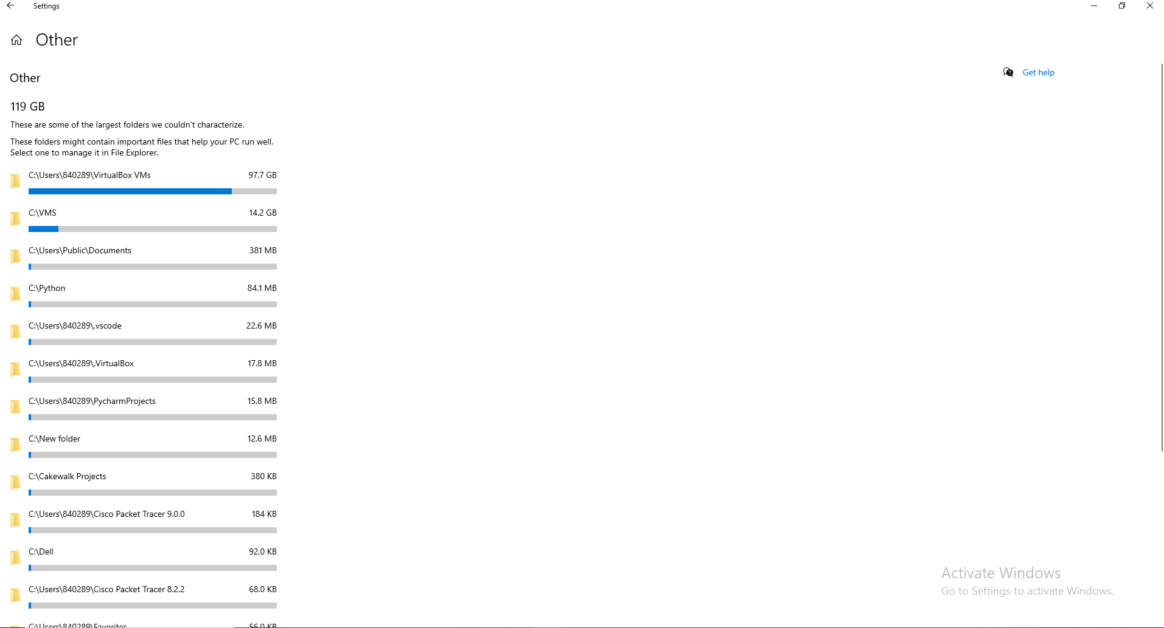

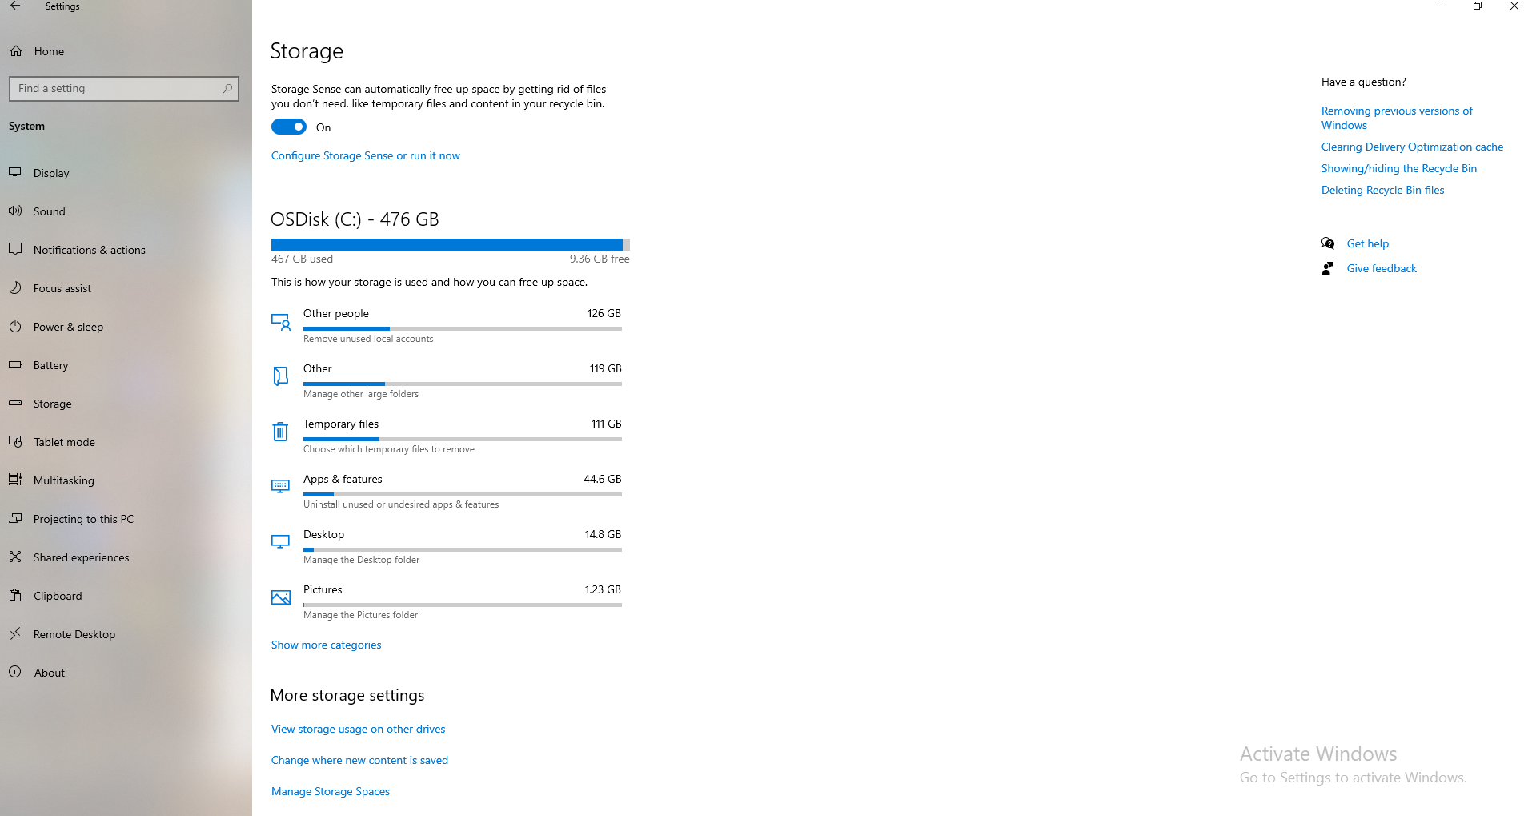

When using Oracle VM VirtualBox, the VM’s virtual disk is stored as a file on the host system. If the host computer’s disk becomes full, which is the issue in this case, the VM cannot expand its disk, write data, or launch properly. This can cause errors, crashes, or data corruption inside the VM, and in this case it prevented the VM from starting

Fixed: by freeing up space
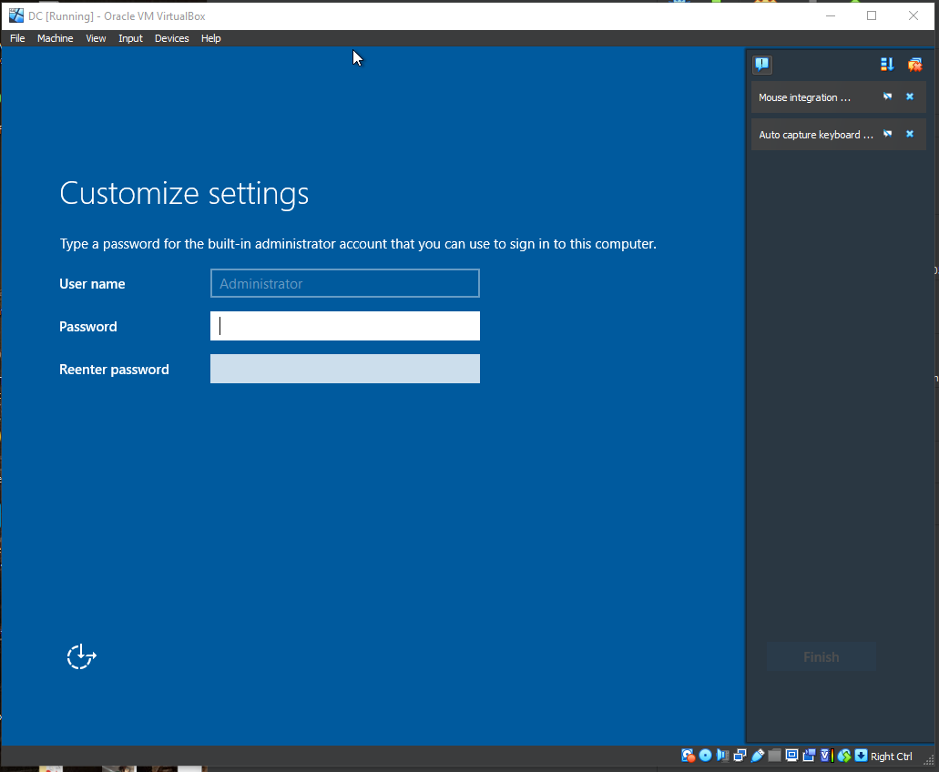

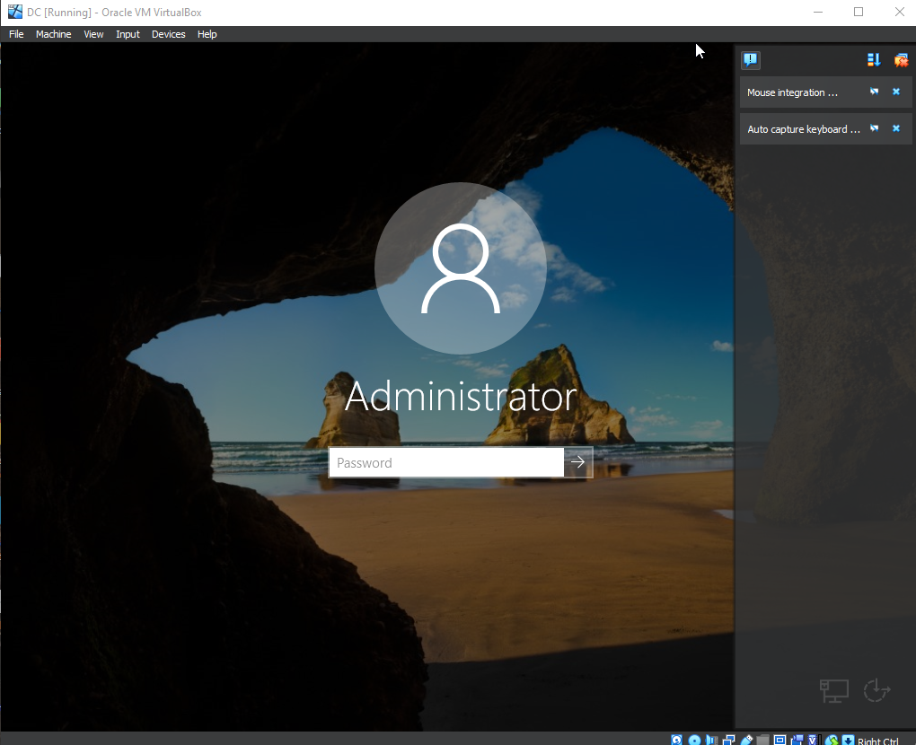

IP Address Configuration

Out of the 2 NIC, the one that on the internet will auto get ip from the router.
Internet Network: set it up manually

Figure how which is internal network and which is connected to internet

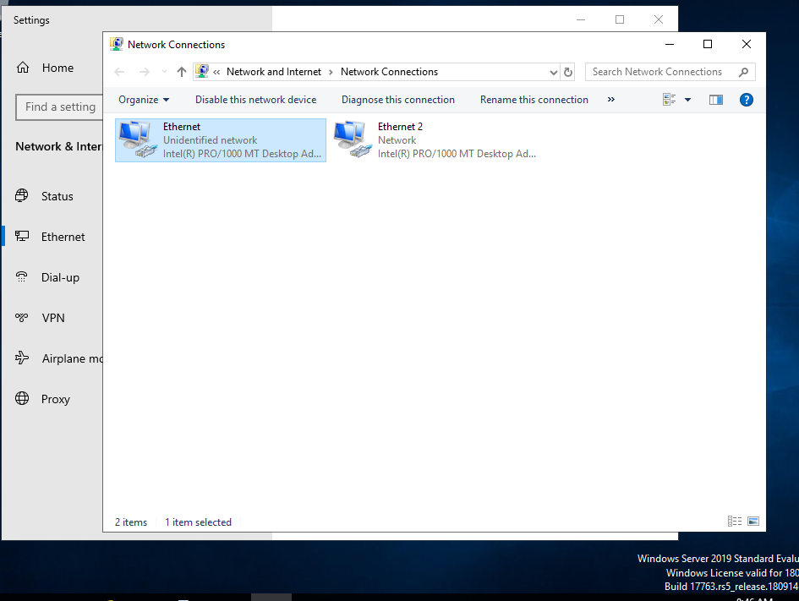

“Ethernet 2” look like a proper home ip address so it probably the one connect to internet

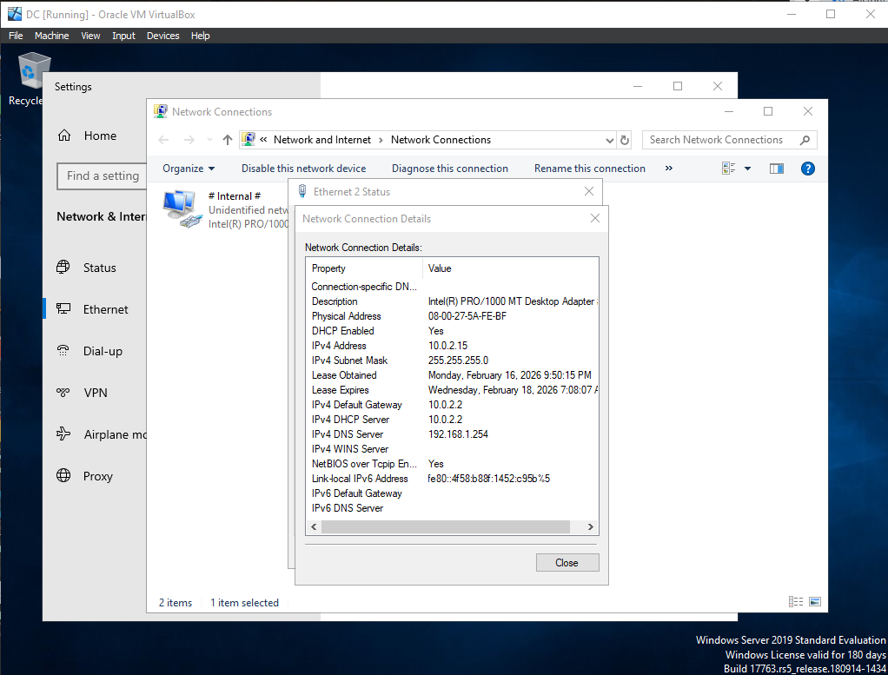

I know “Ethernet” is internal because the 169.254 ip address is an APIPA device that couldn't get an IP address from a DHCP server (which usually router), so it assigned itself one automatically.

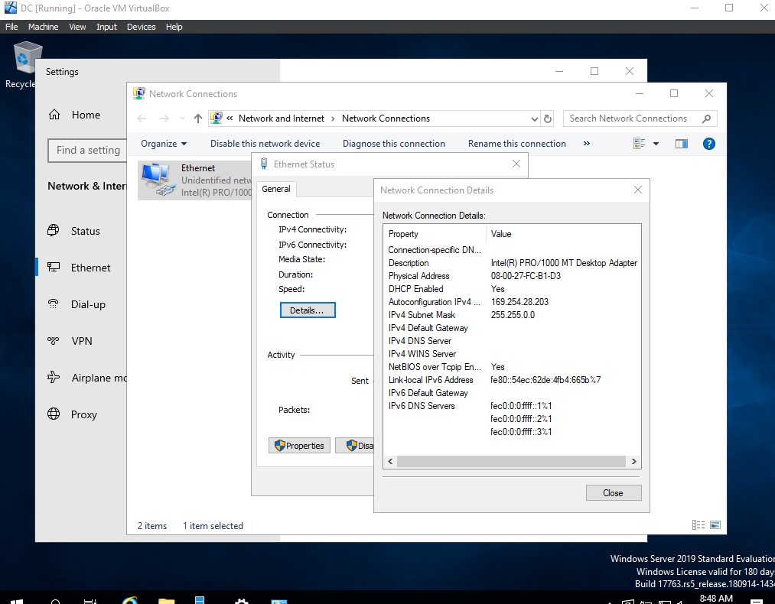

Assigning IP. not default gateway because domain controller will serve as default gateway

When active directory install DNS will automatically be installed

I put loop back address as DNS server because its telling the device to use itself for DNS

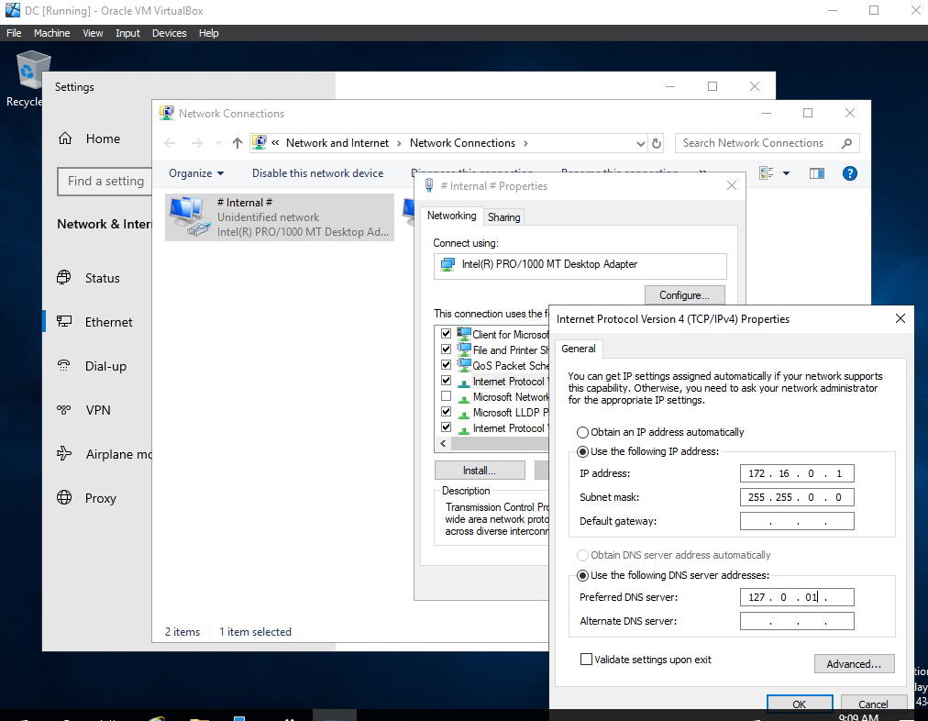

Renaming the Computer

Renamed Network Connections so it easier to work with:
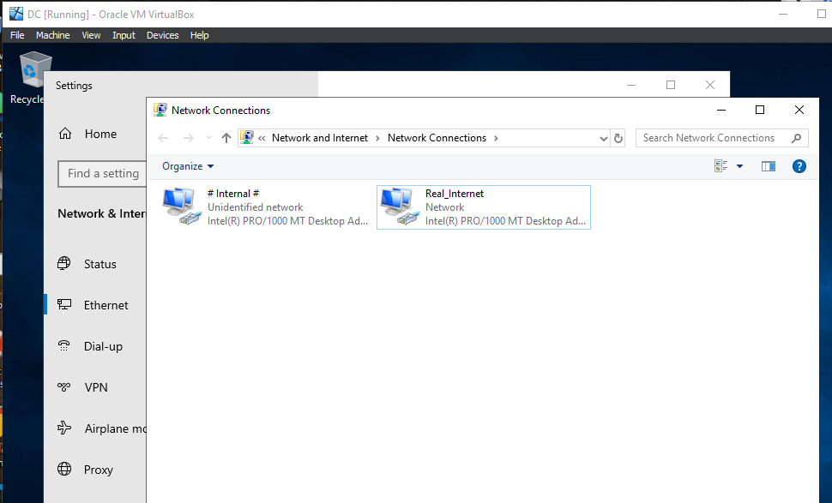

Renaming Pc

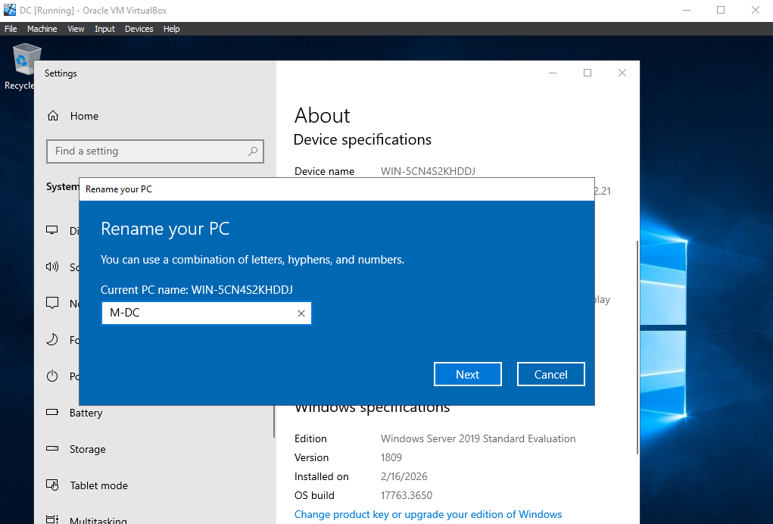

I renamed the server from its default Windows assigned name because default hostnames are randomly generated and do not reflect the server’s role in the network.Renaming the server before promoting it to a Domain Controller ensures proper identification and cleaner integration into Active Directory.

Active Directory Installation and Domain Creation

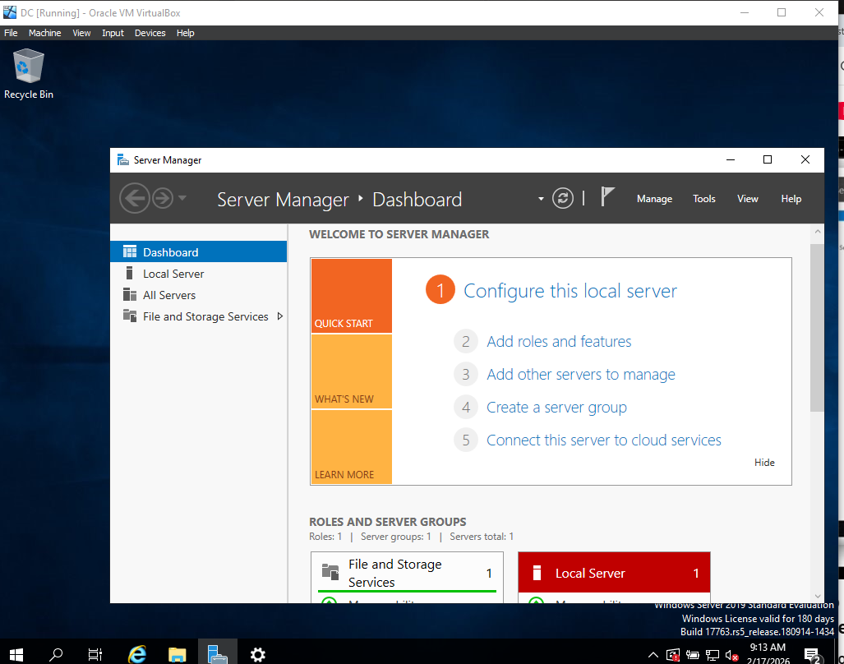

Add roles and Features - > Next

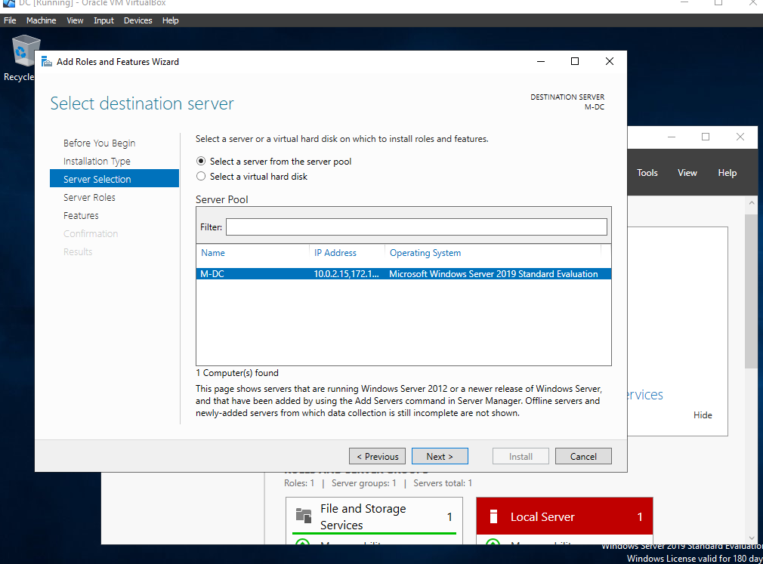
This would be where you'd pick the server where you want to install where u want to instal.,
It asks which server you want to install Active Directory on. Pick the server that will become your Domain Controller

I only have 1 server

Pick Active Directory Domain Services

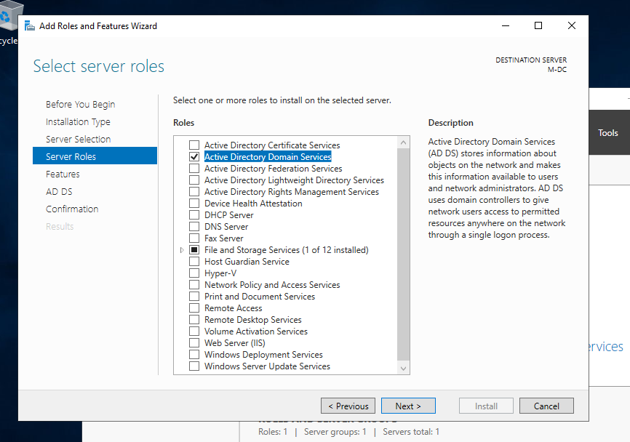

I selected “ Active Directory Domain Services” to be able to run Active Directory and become a Domain Controller for this network

Next >

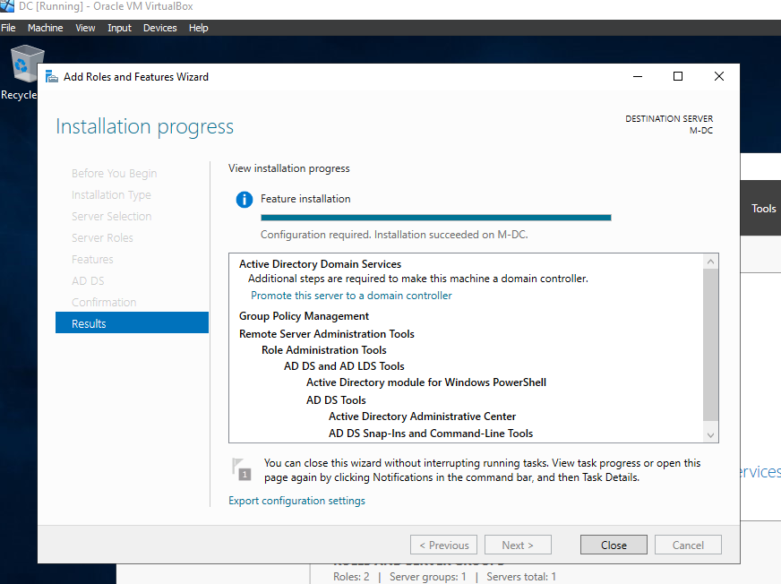

Software installed; domain not created

Post deployment configuration/ Creating Domain

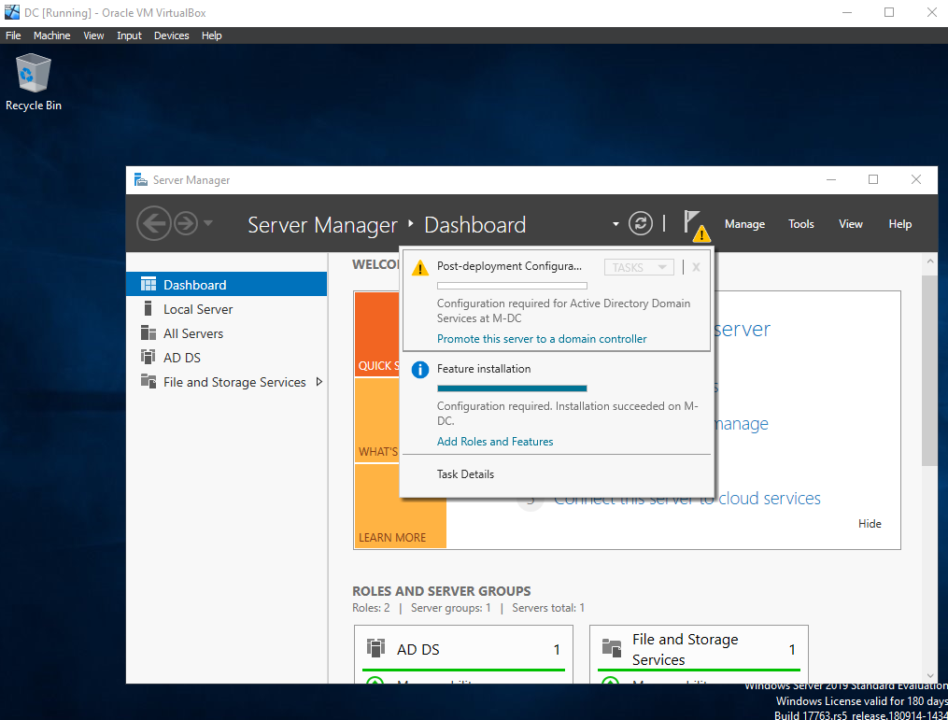
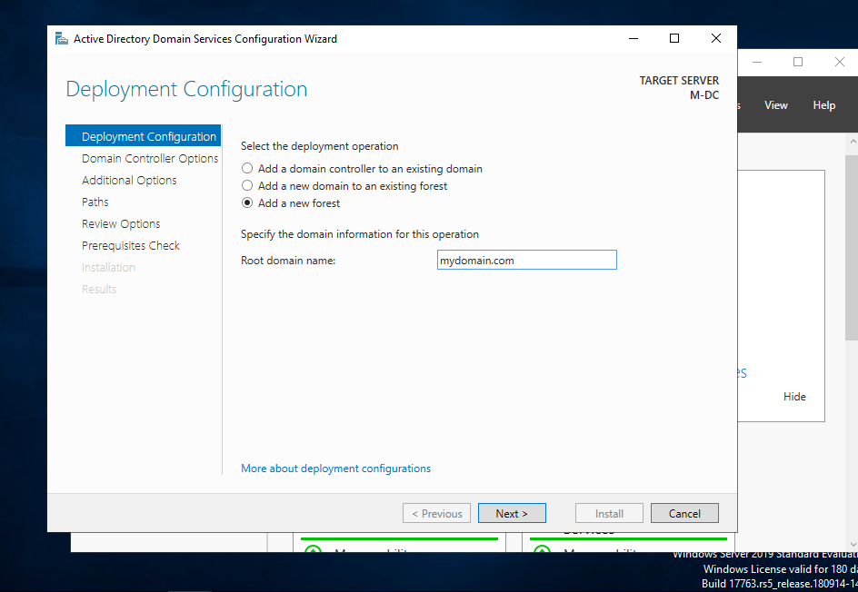

Next >>>> install

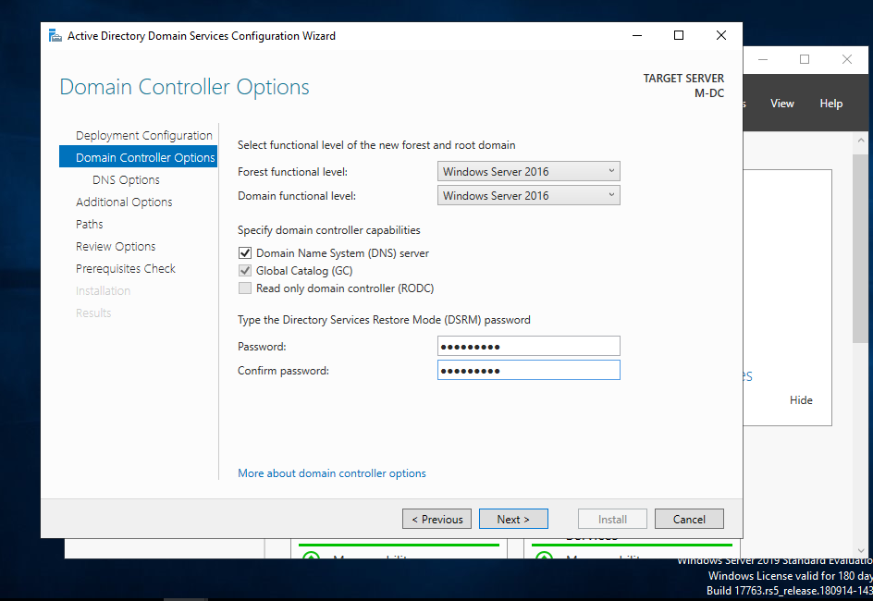

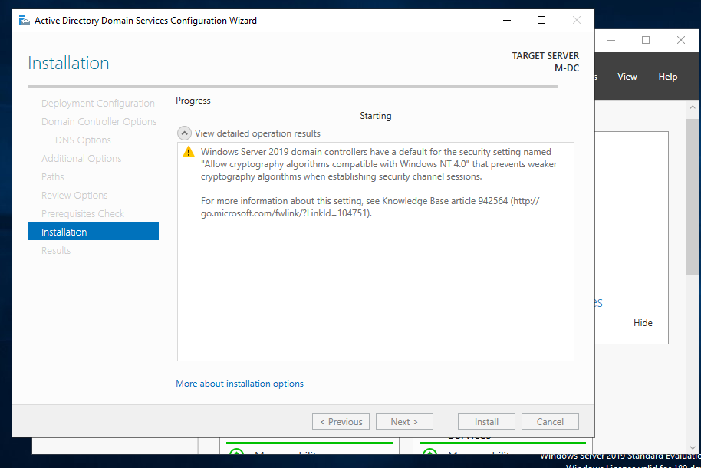

Organizational Unit and Domain Account Creation

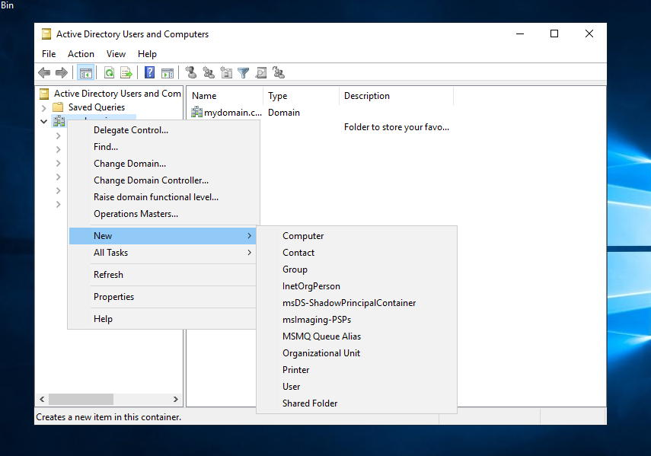
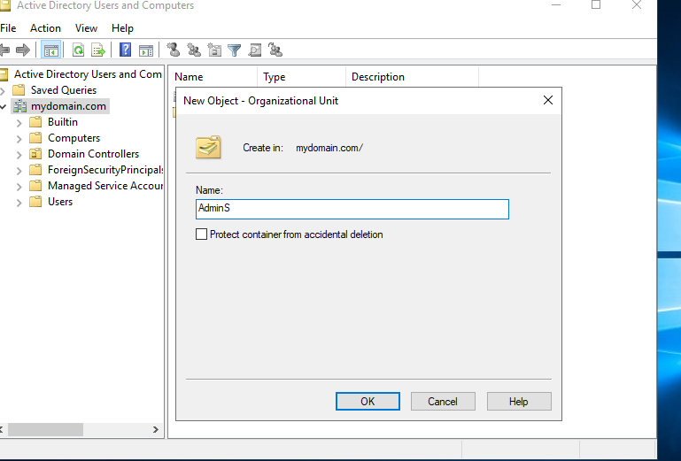

Creating New User
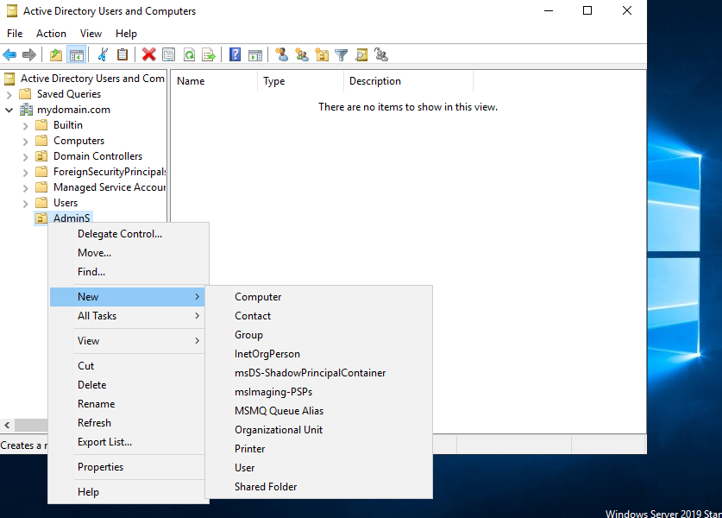

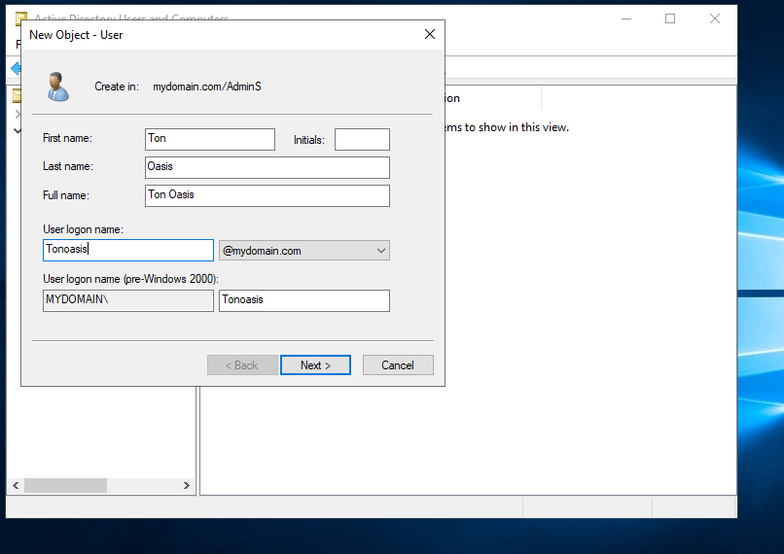
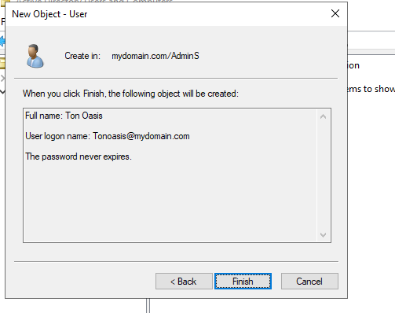

Make admin
Check names
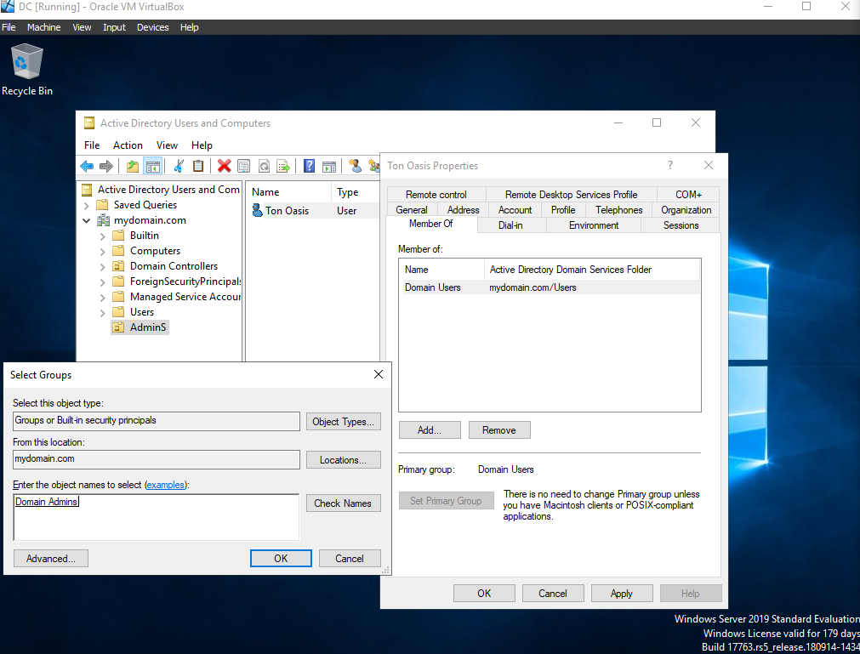

Use Admon account

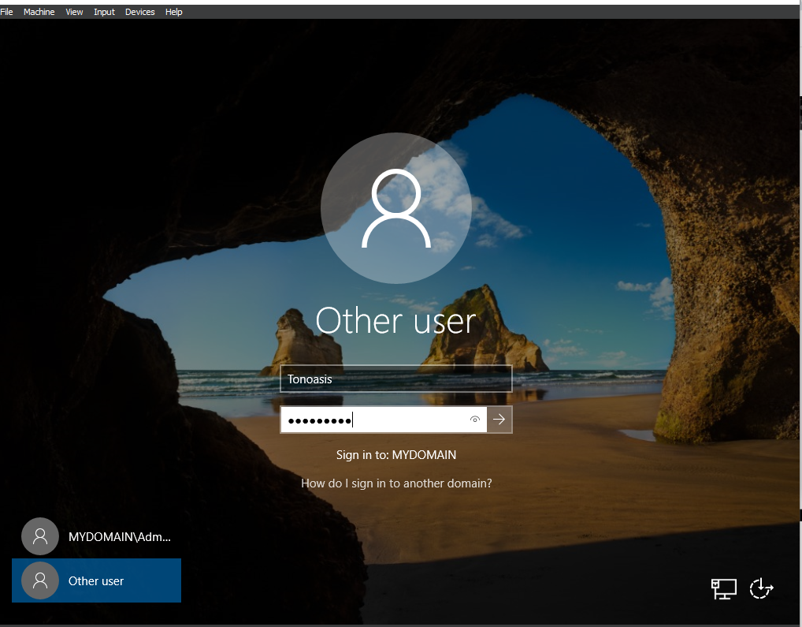

Remote Access and NAT Installation

Remote access server/network address translation

I installed RAS (Remote Access Service) with NAT (Network Address Translation) on the server to allow lab client machines to access the network and simulate internet connectivity. RAS lets people connect to the network from different locations or devices. NAT lets the server I just installed act like a router, so users can connect to resources outside the local network, such as the internet or other servers

Users will be accessing the internet through the Domain controller

Select “ add roles and features”
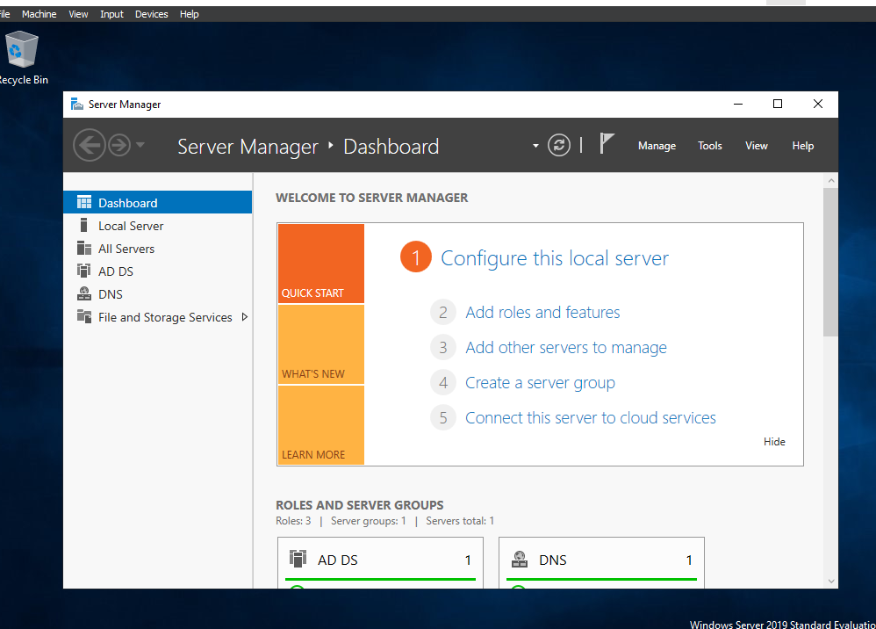

Make sure im picking the DC
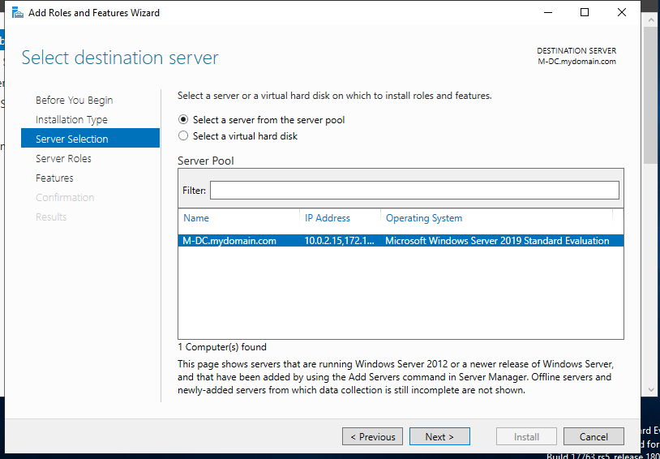

Select remote access:
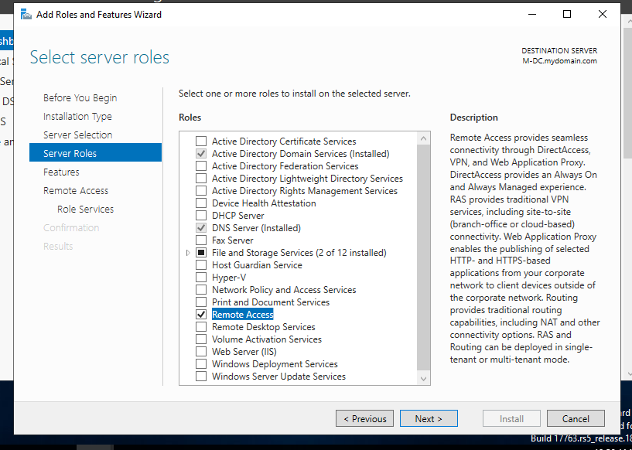

Install routing:
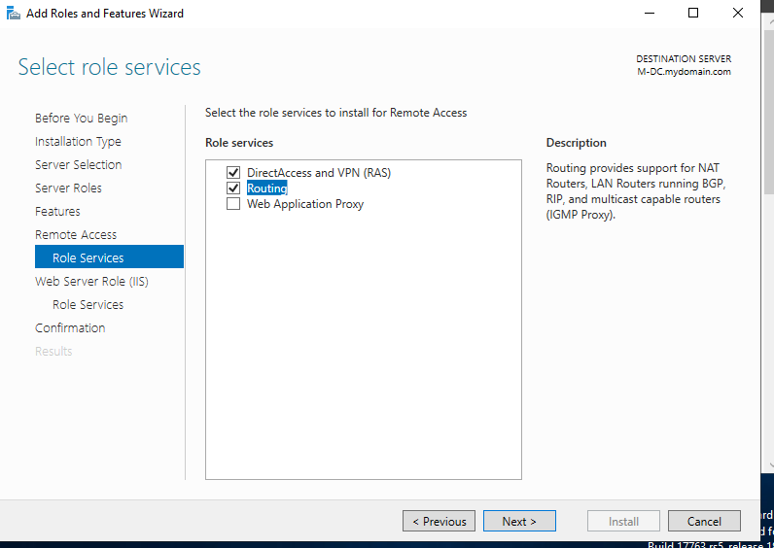
RAS auto selected once picked routing

NEXT >>>>>> Instal
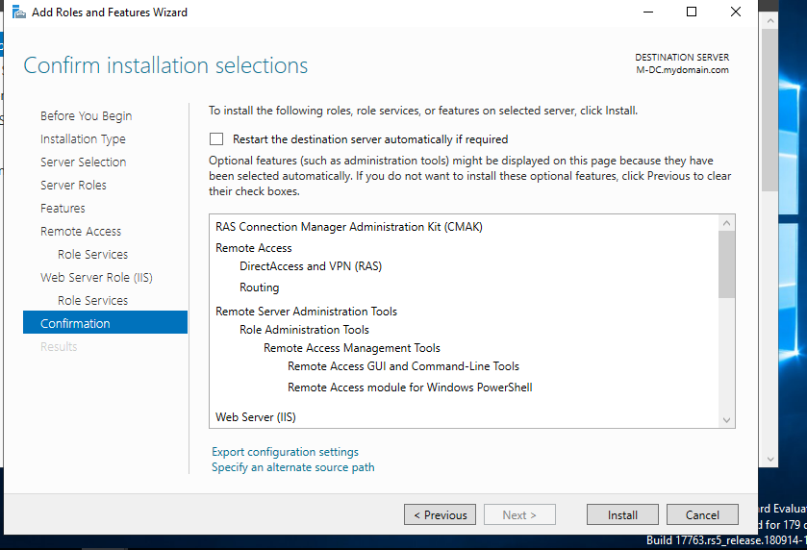
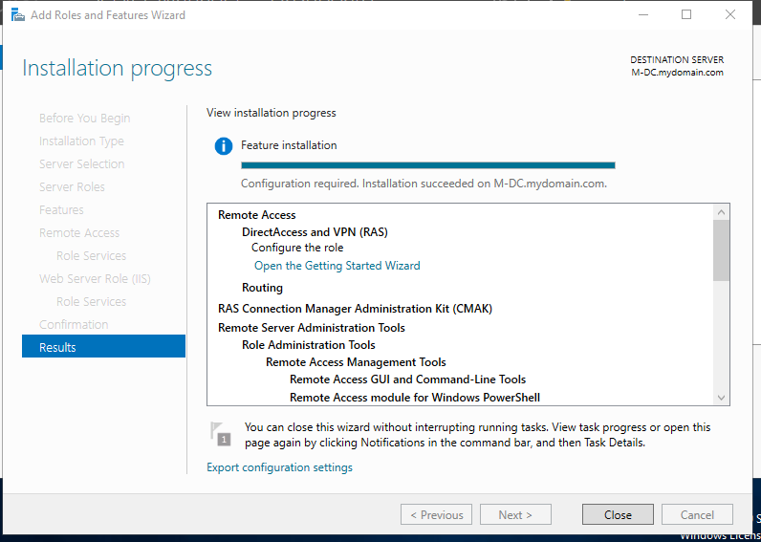

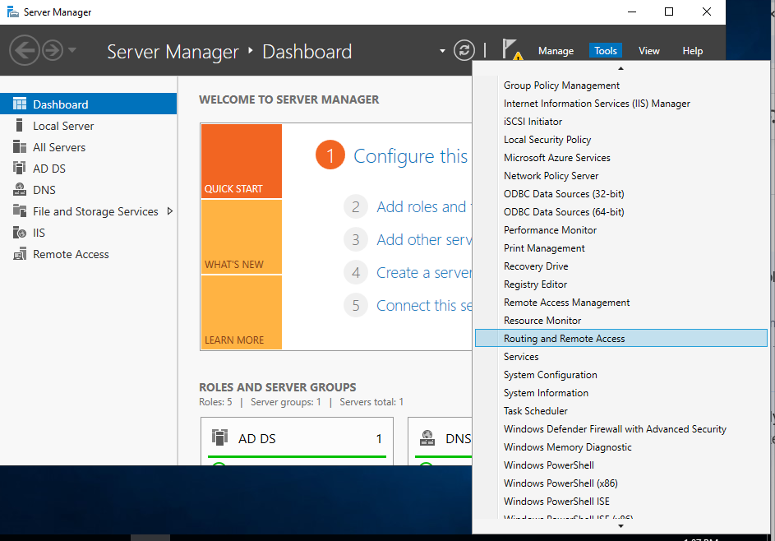

Right click “M-DC”
Click: Configure and Enable Routing and Remote Access

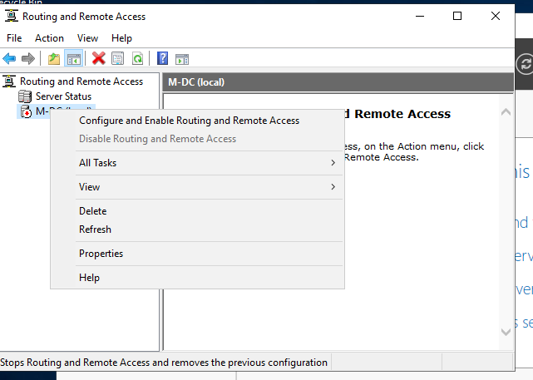

Install NAT
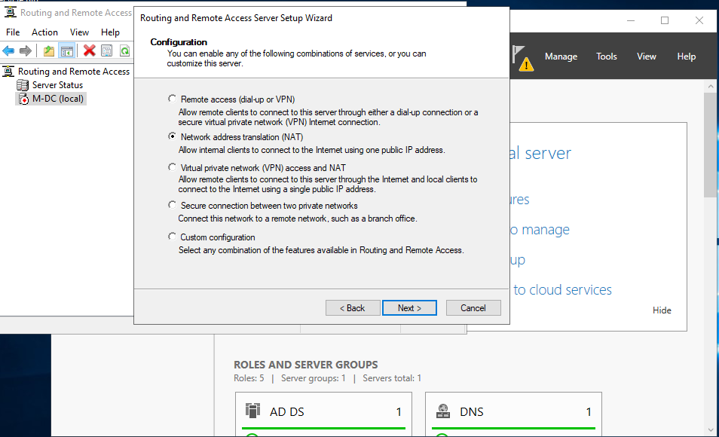

This is why I labeled the Network Connections, so they're identifiable
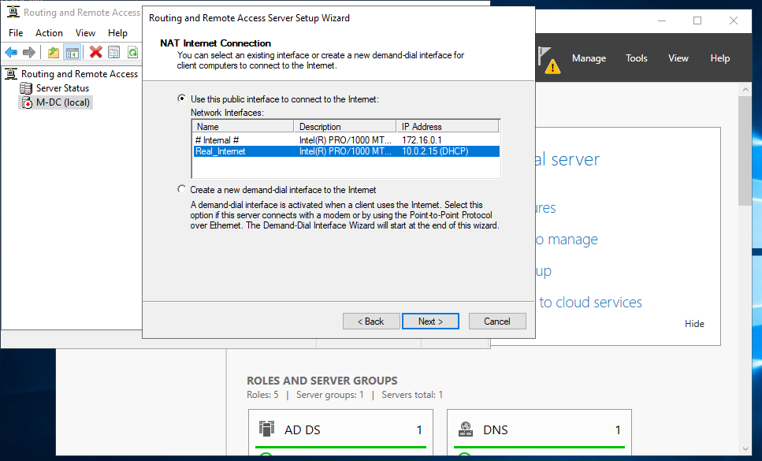

NAT configured
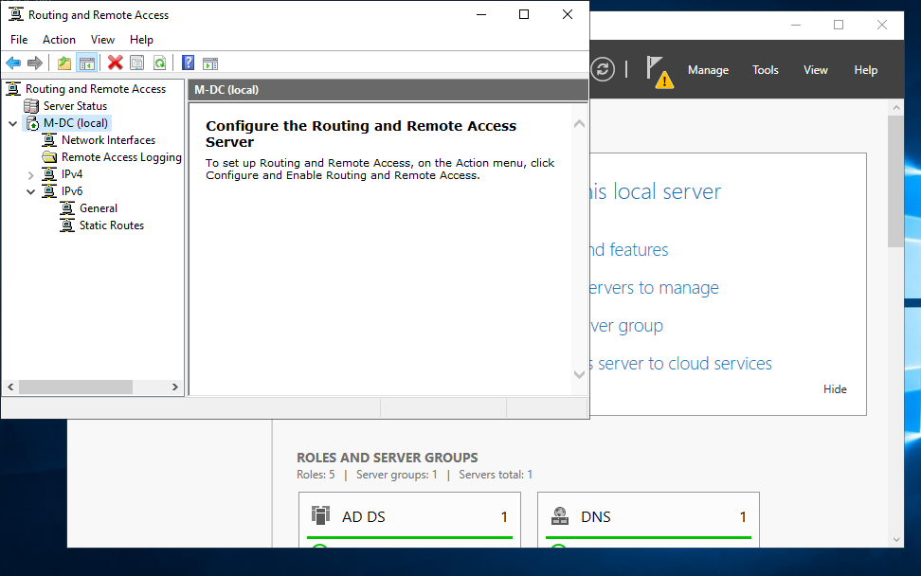

MMC Snap-in Error During NAT Setup
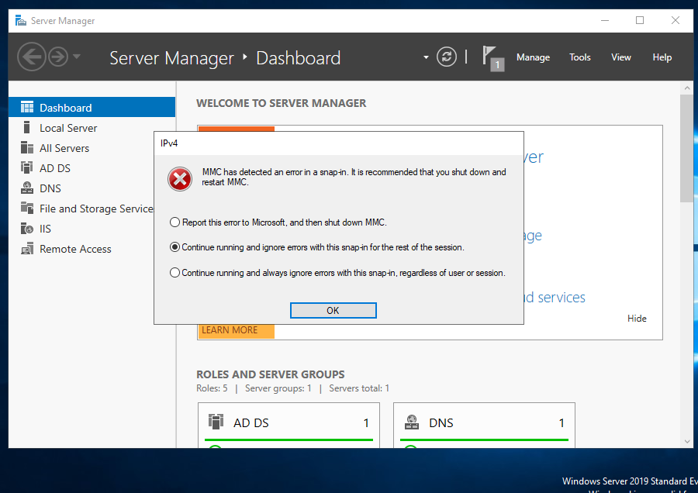
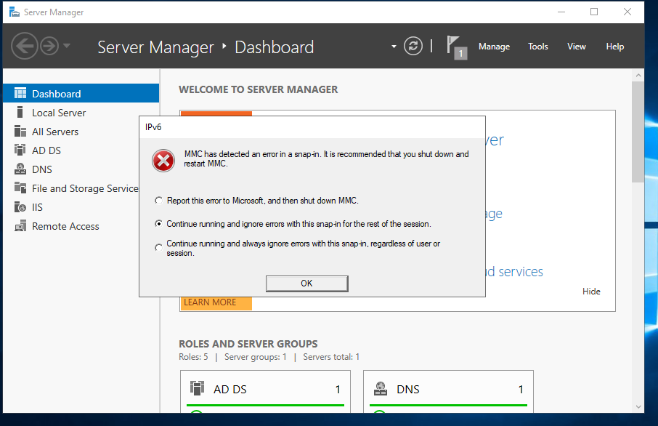

MMC Snap-in Error During NAT Setup
While configuring NAT on the server, I encountered an “MMC has detected an error in a snap-in” message related to both IPv4 and IPv6. This happened because the DHCP role, which works closely with NAT for IP address management, was not yet installed. I chose to continue running and ignore the errors to proceed with the setup. After installing and configuring DHCP and restarting the server, these errors should no longer appear.

DHCP Configurations

DHCP (Dynamic Host Configuration Protocol) allows Windows clients to automatically get an IP address so they can communicate on the network, to access the internet, even when they are on a private lab network

> it just ensures every device has the right network configuration to communicate

Add roles and features > Select DC Server that have been using (only 1)

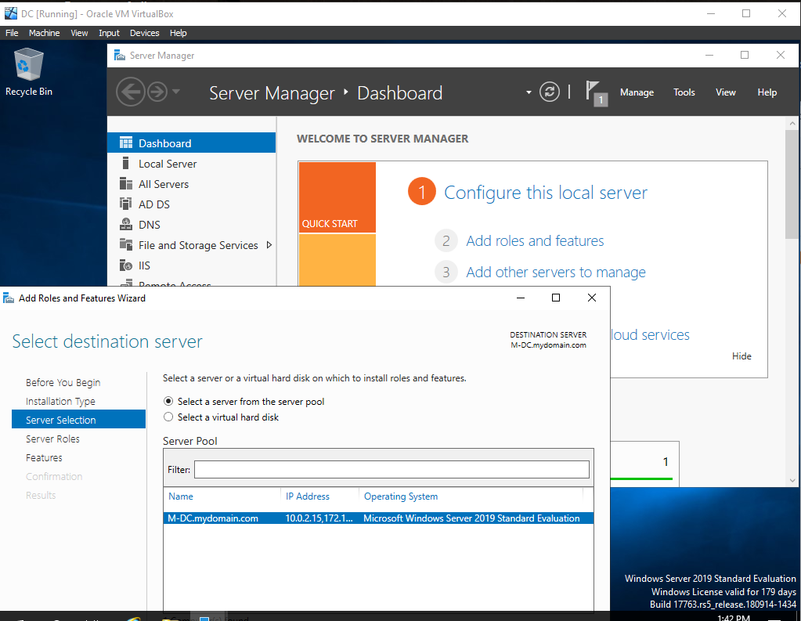

Add DHCP: 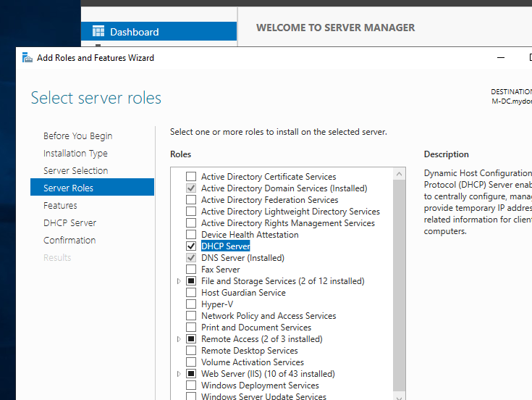

Next >>>> Install

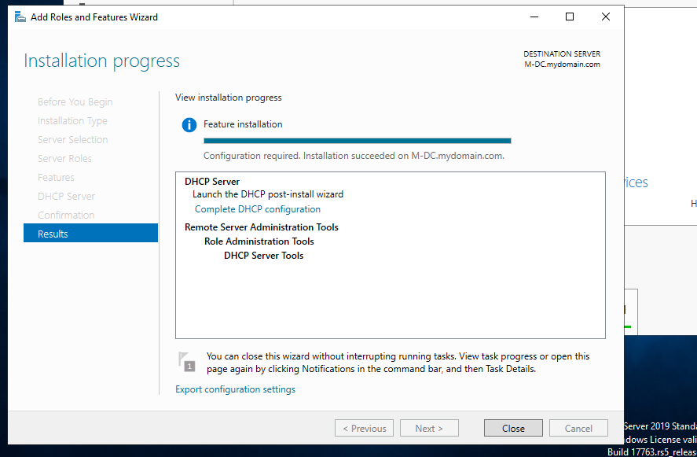

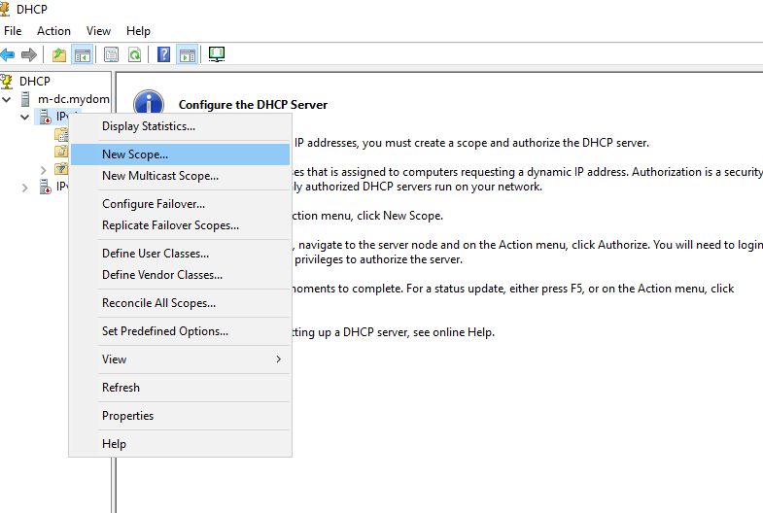
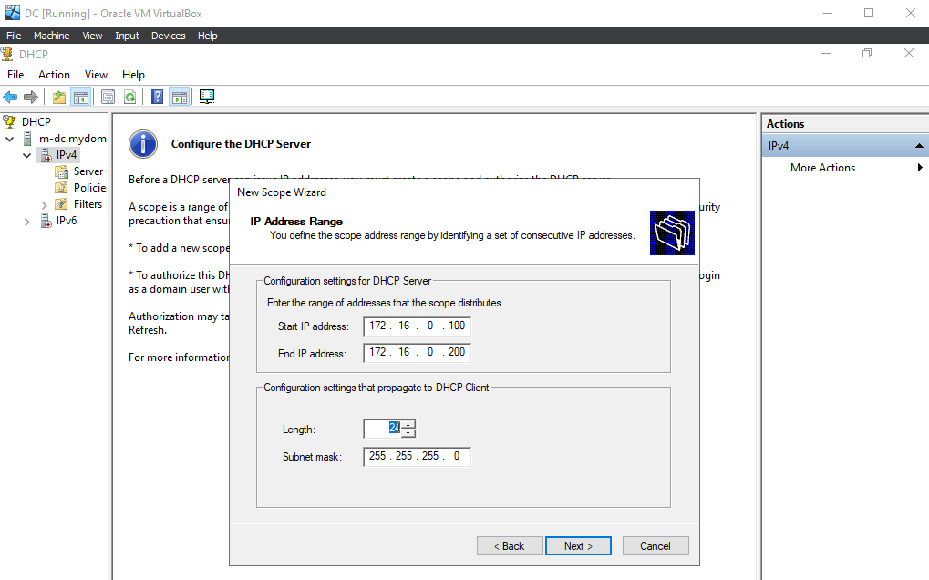

Nat and routing is configured on the domain controller. Among other things its job is to forward traffic from clients to the internet. Clients will use internal NIC of Domain controller as their Router (Default gateway)

-> Entered DC ip address + Click add
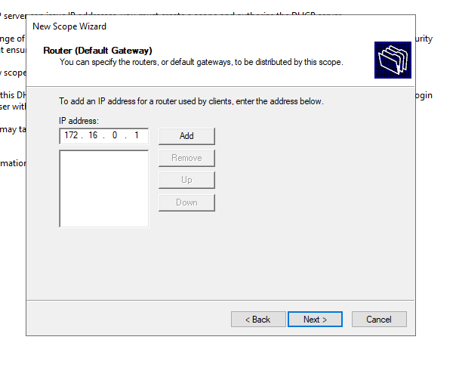

After Done configuring
- Authorize + Refresh

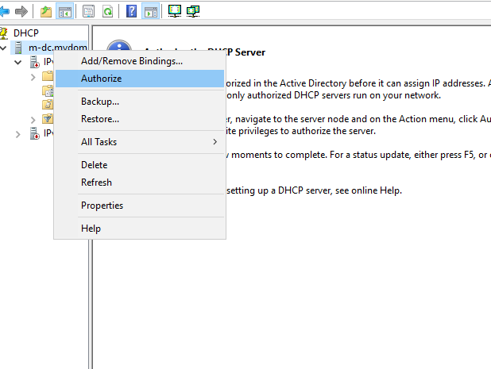

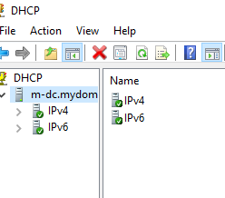

Connected.

DHCP does not have to be on the DC. It can run on a separate server on the network. What matters is the DHCP server must be able to communicate with the network and provide IP addresses to clients.

People sometimes put DHCP on the DC's Fewer servers to manage and everything centralized, mostly in smaller environments. but in larger environments, separate servers are better

If DHCP is on a DC, make sure Active Directory permissions are properly configured

Internet Browsing on Domain Controller
Making a configuration to browse internet

This step verifies that the Domain Controller can access external networks through NAT and the configured network settings

I configured the Domain Controller to browse the internet to confirm that NAT and routing are working correctly in the lab environment. This allowed me to verify external connectivity and ensure the network was properly configured. While this is acceptable for testing in a lab, in real world environments Domain Controllers should usually be restricted from internet browsing because they are critical servers that manage authentication and store sensitive directory data. Allowing web access can increase security risks, so in production environments these servers are typically locked down and limited to essential services only

Click configure local server
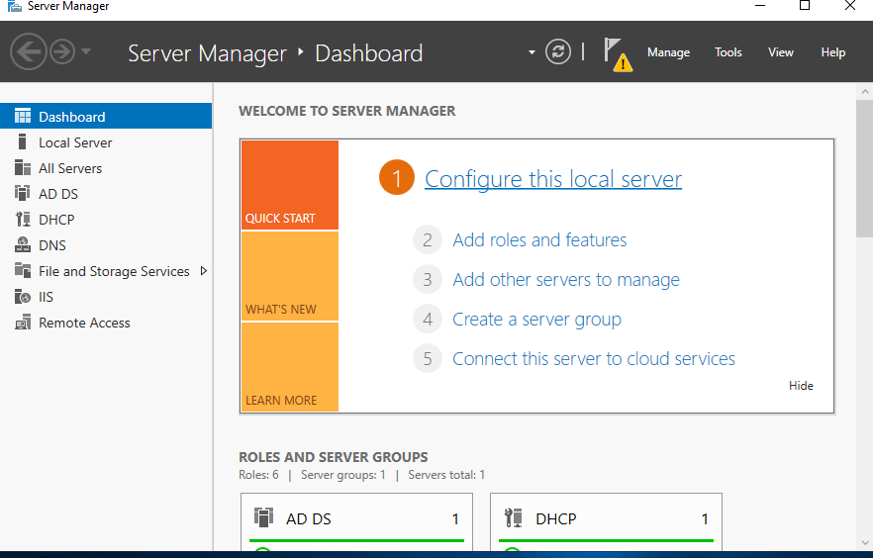
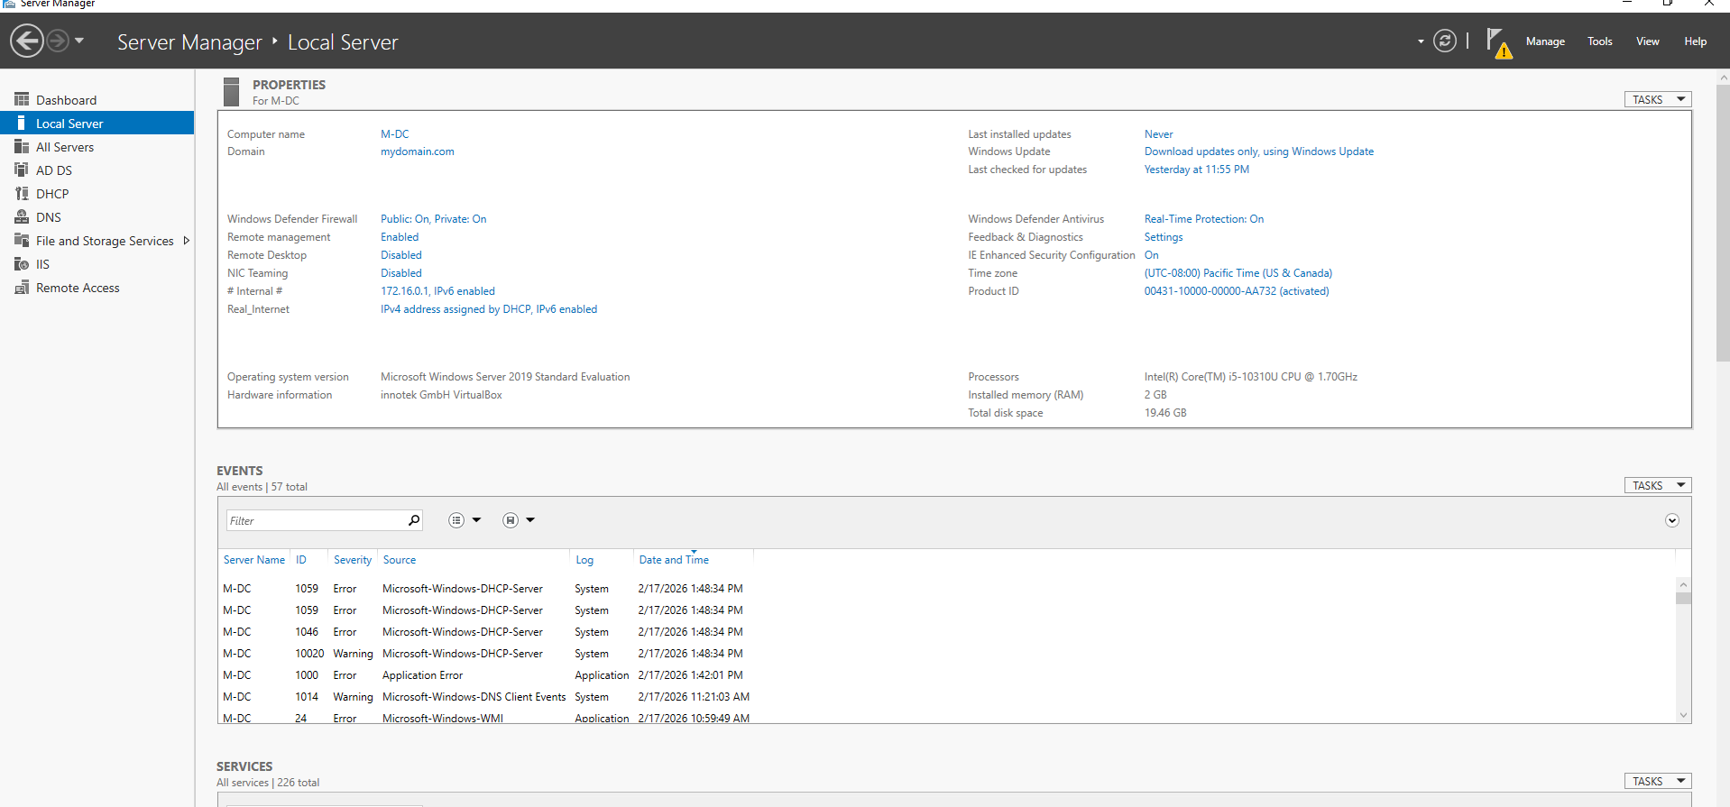

I disabled Internet Explorer Enhanced Security Configuration (IE ESC) for both administrators and users to allow easier web browsing during lab testing. IE ESC is designed to restrict web content and reduce exposure to potentially harmful websites on server systems. While disabling it improves usability in a lab environment, in real-world production environments it is typically left enabled to maintain stronger security controls on critical servers such as Domain Controllers.

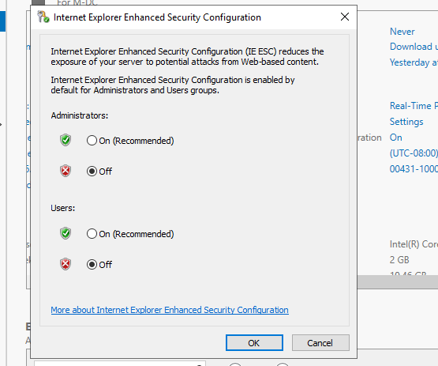

Clicked ask me later

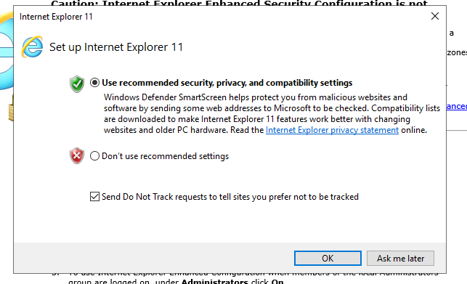
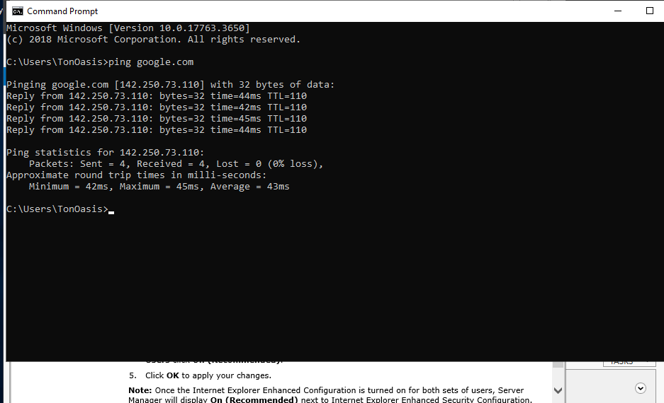
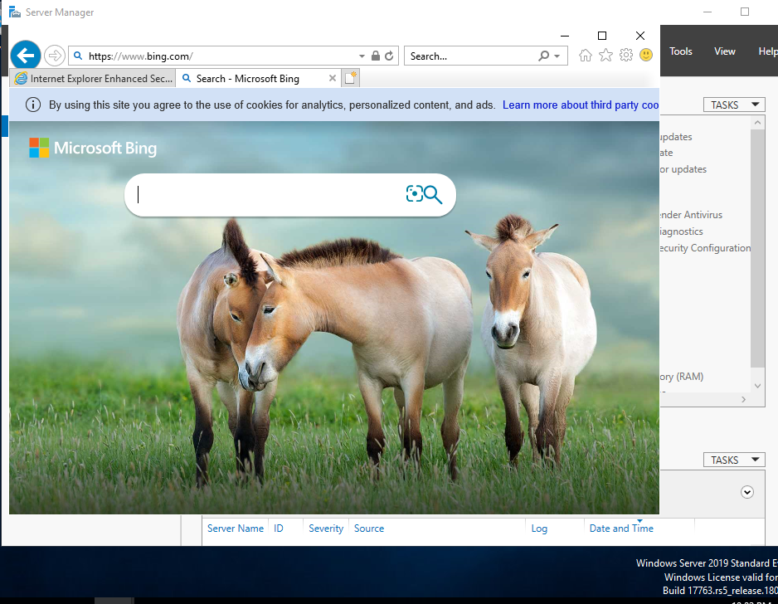

I tested internet connectivity on the Domain Controller by pinging an external IP address and opening a web page (Bing). Both tests were successful, confirming that NAT and routing were configured correctly and that lab clients could access the internet through the server.

Powershell Scripting
> Run as admin
Want to create users in active directory

I am using PowerShell to create users in Active Directory to better simulate a real world IT environment. scripting to automate tasks such as user account creation instead of relying only on the graphical interface. This approach improves efficiency, ensures consistency, and helps me develop practical enterprise level system administration

~ policy change screen shot~
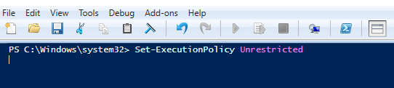
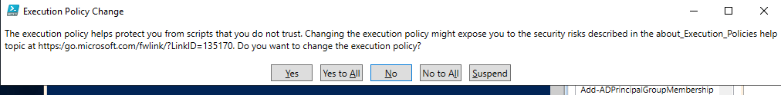

Click: Yes to All

I modified the PowerShell execution policy so I could run the automation scripts needed for setup. By default, Windows uses the Restricted policy, which blocks all scripts from running as a security precaution. Other options include Unrestricted, which allows all scripts to run but reduces security protections, and RemoteSigned, which allows locally created scripts to run while requiring downloaded scripts to be signed. For this lab, I used Unrestricted specifically to ensure the required AD setup scripts could execute without any interruption in my controlled VM environment. Since this is an isolated lab and not a production system, the reduced restrictions are acceptable for learning and testing purposes.

For this lab, I sourced a PowerShell automation script from an online repository and implemented it within my environment.
Below shows: reviewing and modifying it to understand how each command functions

~ script screen shot~
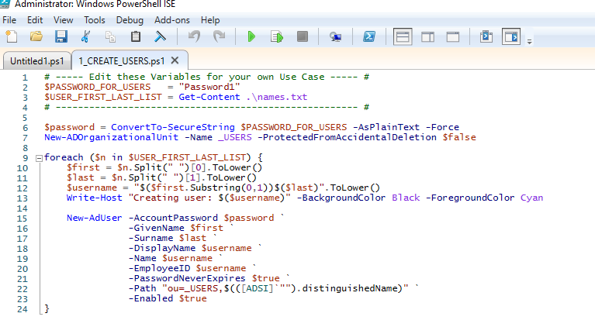

Explanation:
per line #

all users will have the same initial password; good only for a controlled lab
#2 - “Password1” will be the password all user account sawmill be using, all users will have the same initial password; good only for a controlled lab

#3 = the “Get-content” form .\names.txt ; means it will be getting all the names from the txt file filled with names and pasting it in the variable “ $USER_FIRST_LAST_LIST “ like an array

Txt file: 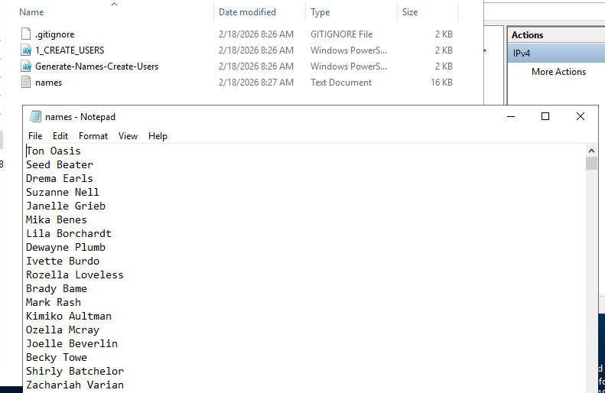

#6 will take the plain text password “Password1” into a more secure password for powershell

#7 creates a new OU (organization unit) called “_Users” here: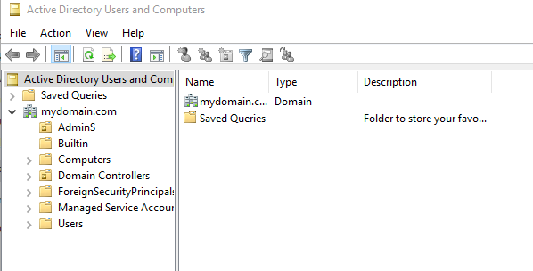

#9 = “foreach”
Is a loop that that block of code 9-24 will run for each user

Each “$n” represents the current user being examined. Ex id be the first ‘$n” Ton Oasis


#10 = split from space in note pad and take element 0; which is first name and store it in “$first”

#11 = split form space and take element 1; which is last name and store it in “$last”

#12 = Username variable take first name first character and attach it to last name and lowercase it ex: Ton Oasis = toasis / Seed Beater = sbeaterer

13 = alert users being created

15 - 23: making new user and assigning credentials based of what listed

Execution:
Go to director where script is at

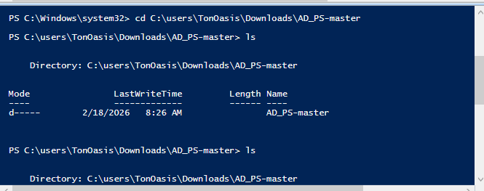
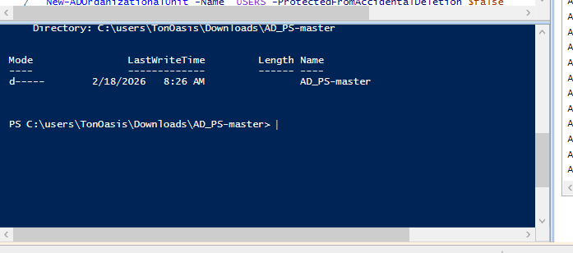
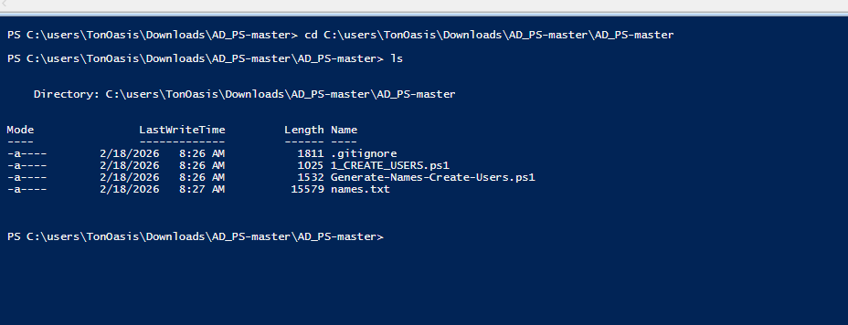

Run

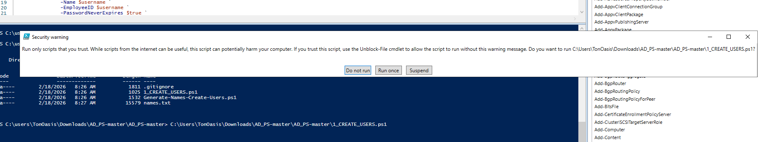

Before & after:
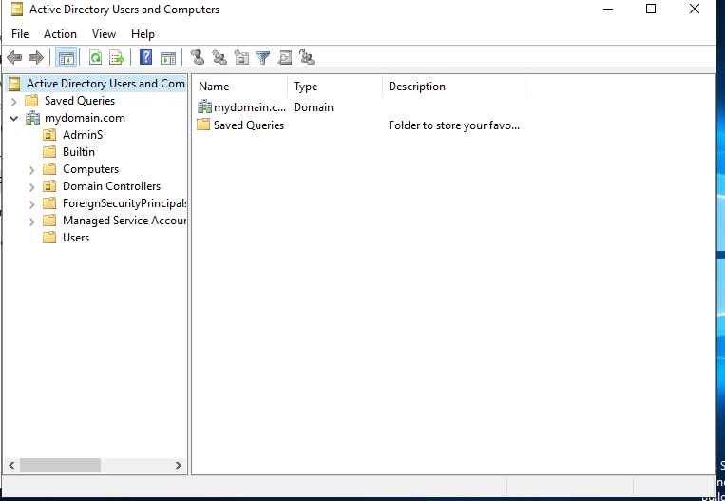
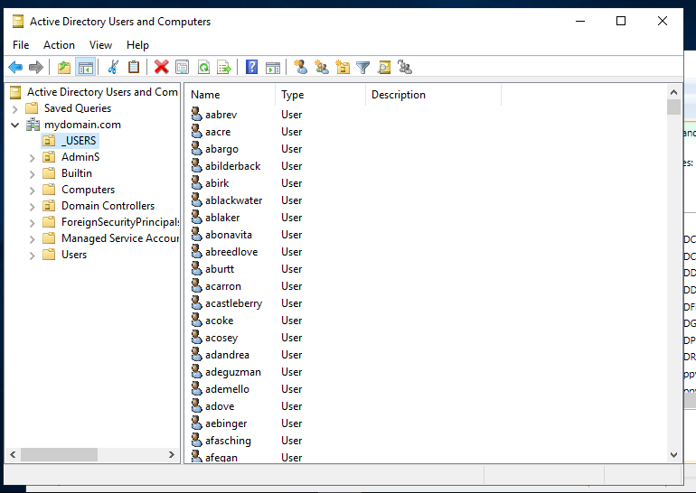

Found normal and admin account
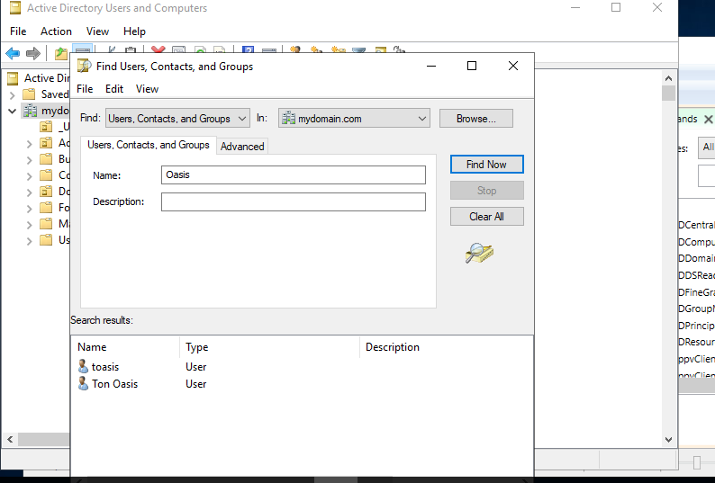

Windows 10 Client Creation VM

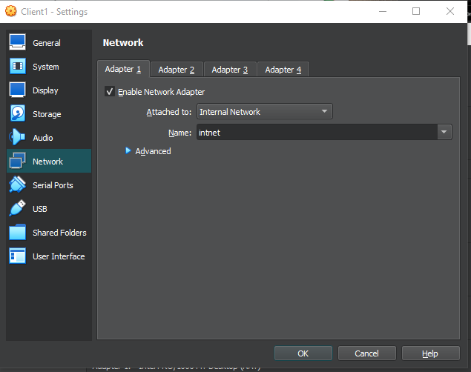

Instead of using NAT to connect to my home/host PC network, I set the client1 VM to an internal network to simulate a device within a LAN or office environment. I initially gave the Domain Controller two NICs so that this client PC VM can connect directly to the DC and receive a DHCP address, ensuring proper communication and domain services for the lab

User 1 can reach Dc, but it current not getting internet from it

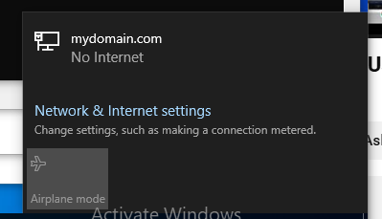
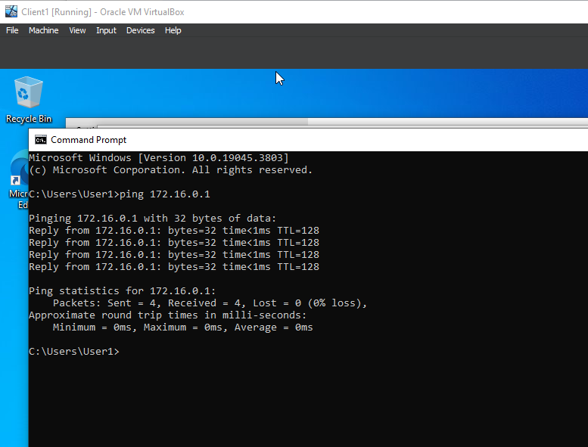

I verified DNS functionality using the nslookup command from the client machine. The results confirmed that the domain name to the Domain Controller’s internal IP address (172.16.0.1), demonstrating that the client was correctly using the Domain Controller as its DNS server. Since Active Directory depends on DNS for domain services and authentication, this confirmed proper domain communication within the lab environment.

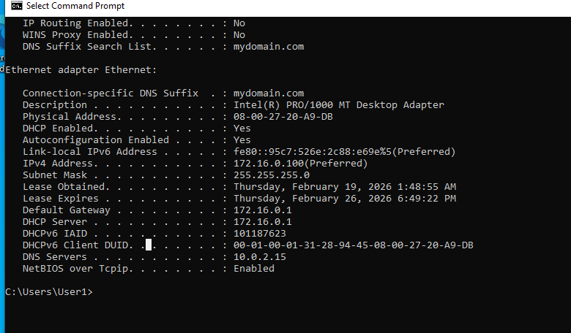

DHCP scope on the DC is handing out: 10.0.2.15 instead of 172.16.0.1

During DNS verification, I observed that the client machine was using the Domain Controller’s NAT adapter IP (10.0.2.15) as its DNS server instead of the internal network IP (172.16.0.1). Since Active Directory relies on internal DNS resolution, I corrected the DHCP scope option (006 DNS Servers) to distribute the DC’s internal IP address. After renewing the client’s lease, DNS was properly configured, ensuring accurate domain service resolution.

Fix:
Open DHCP
Go to IPv4 >> Scope Options
Find 006 DNS Servers
Changing it it to: 172.16.0.1 (remove 10.0.2.15)
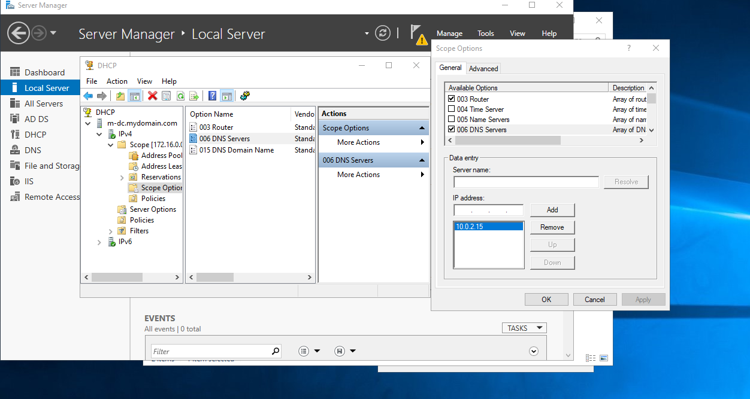
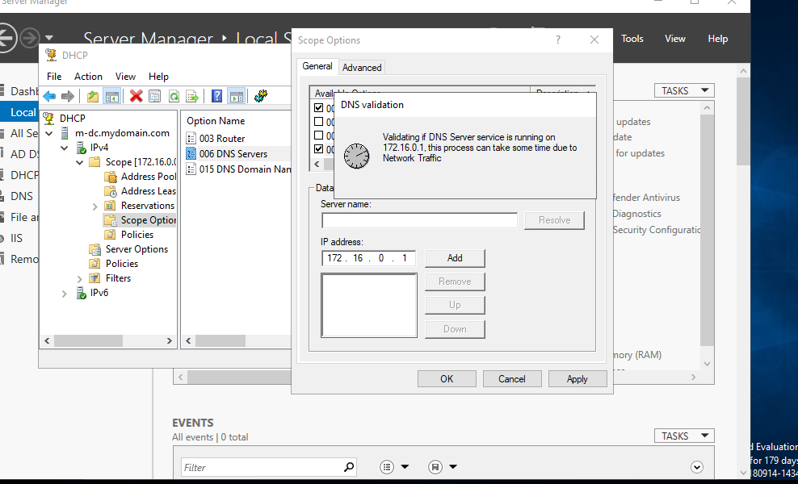
After Changing It

I ran on Client1 run:
ipconfig /release
ipconfig /renew
ipconfig /all
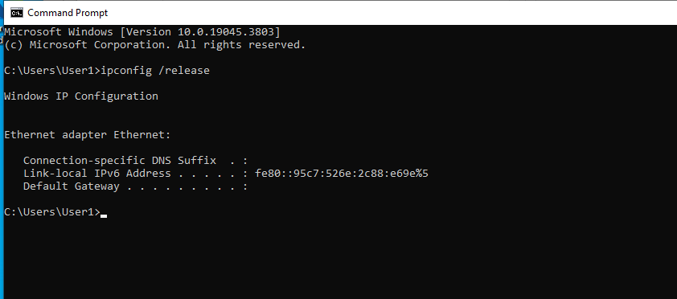
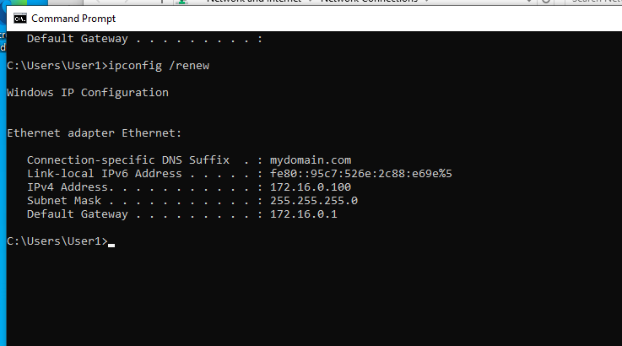
DNS should be: 172.16.0.1
Default Gateway should be : 172.16.0.1
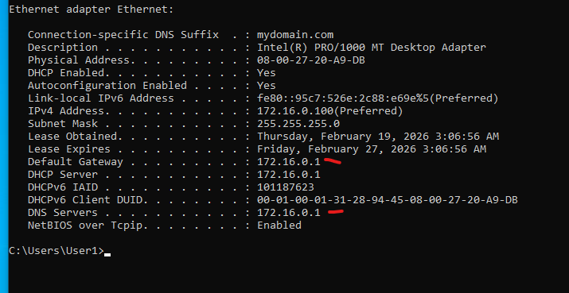

Client1 - Uses >> Domain Controller(172.16.0.1) for DNS
Client1 – Uses >> Domain Controller (172.16.0.1) for routing
Domain Controller(172.16.0.1) – Uses > NAT adaptor (10.0.2.15) > Host PC – > Internet

Still Cant ping Google
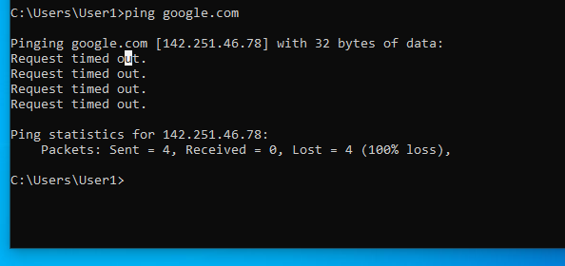

On the DC:
Open Network Connections
Right-click the NAT adapter (the one that has internet)
Click Properties
Go to the Sharing tab
Check:
“Allow other network users to connect through this computer’s Internet connection”
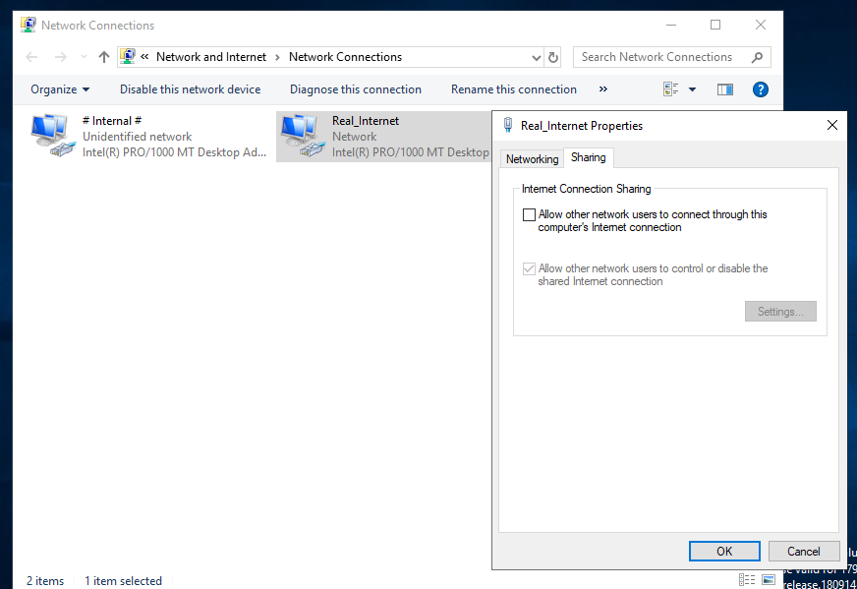
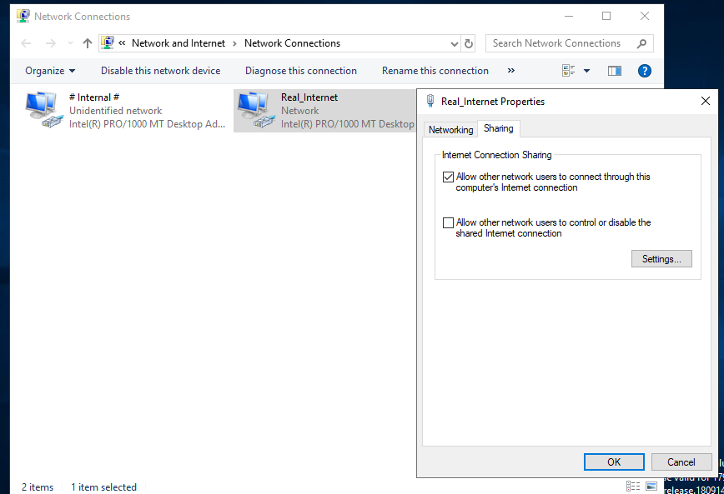

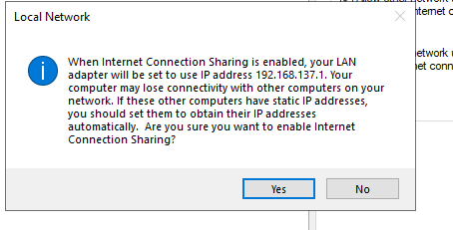

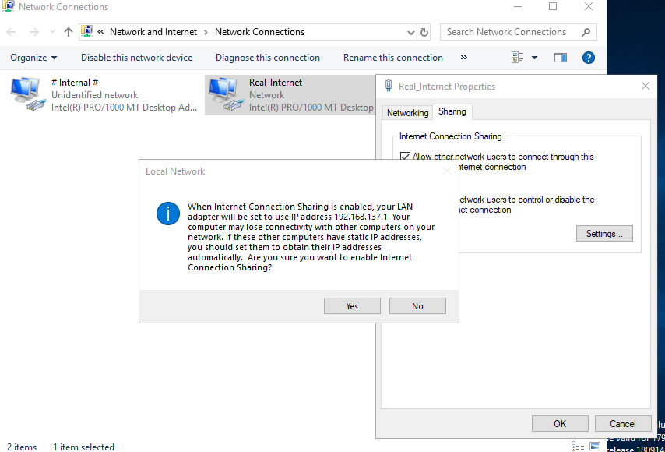
Internet Connection Sharing Decision
While configuring internet access for the internal lab network, I attempted to enable Internet Connection Sharing (ICS) on the Domain Controller’s NAT adapter. However, Windows displayed a warning indicating that enabling ICS would automatically reconfigure the internal LAN adapter to use the IP address 192.168.137.1, potentially disrupting existing network settings.
Since my lab environment was already intentionally configured with a 172.16.0.0/16 internal network, including DHCP scope, DNS settings, and Active Directory integration tied to that address space, enabling ICS would have overridden the manual configuration and broken the designed network structure.
Instead of proceeding, I selected Cancel to preserve the existing AD network configuration. This decision ensured that the internal addressing scheme remained consistent and allowed for a more enterprise appropriate routing solution (such as configuring RRAS) rather than relying on Internet Connection Sharing.

I chose Cancel when Windows warned that enabling Internet Connection Sharing would reset the internal adapter to 192.168.137.1, which would have broken my AD lab’s 172.16.0.0/16 network, DHCP, and DNS configuration. Preserving the existing setup allowed me to maintain proper domain functionality and plan a cleaner enterprise style routing solution using RRAS.

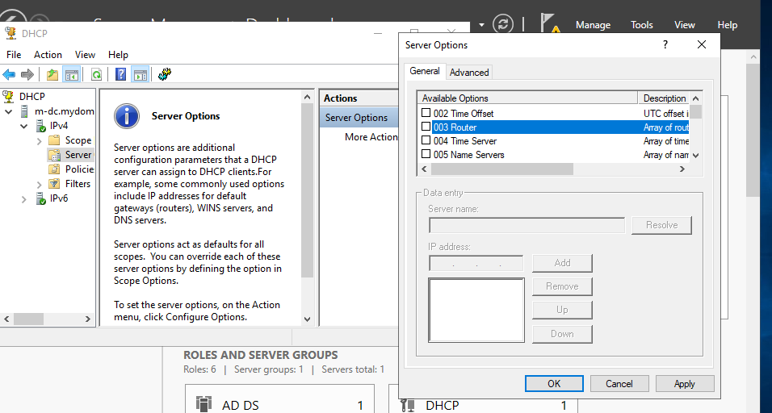
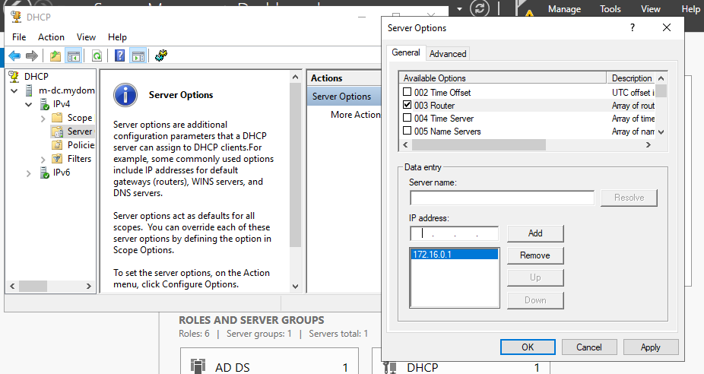

Restart Server:
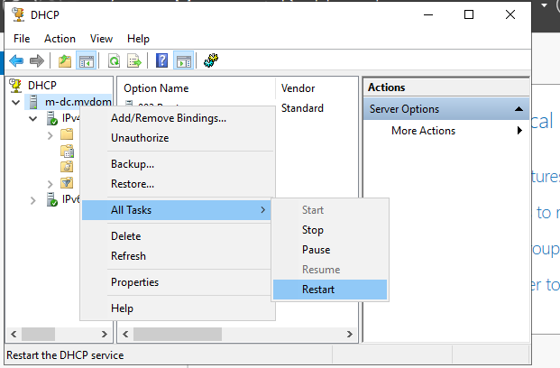

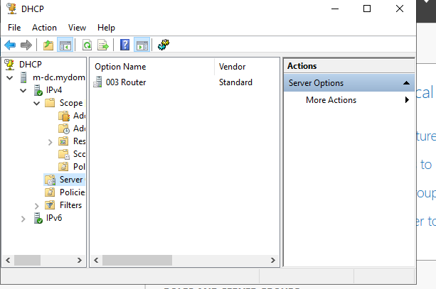

Still Not working

Client1 is fully connected to the internal network:
- It can see the DC via ping
- It has an IP from your DC’s DHCP
- It shows up in the DHCP lease list

What’s failing
- Only the internet access is not working.
- That’s because the DC is not forwarding traffic out to your host PC’s NAT adapter

Troubleshooting
I was able to troubleshoot by identifying misconfigurations, understanding the flow of network traffic through a lab AD environment, and apply the correct settings to achieve functional connectivity without disrupting internal domain services.
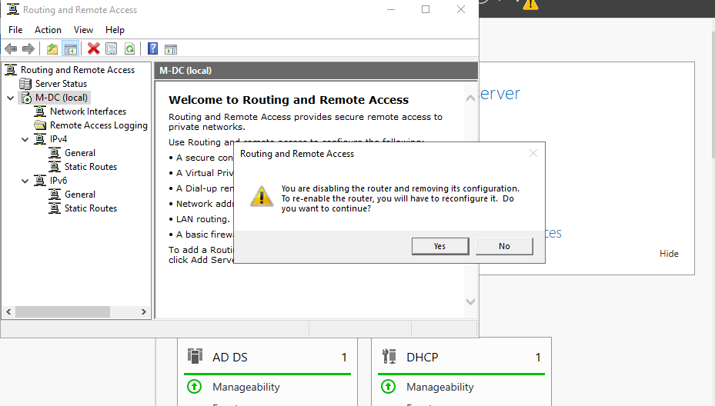
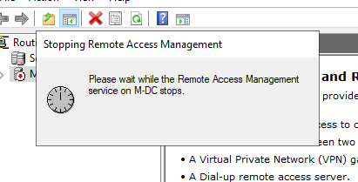

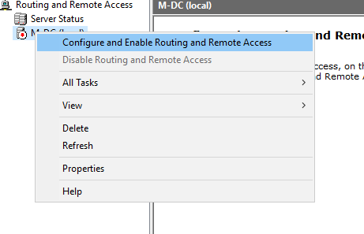

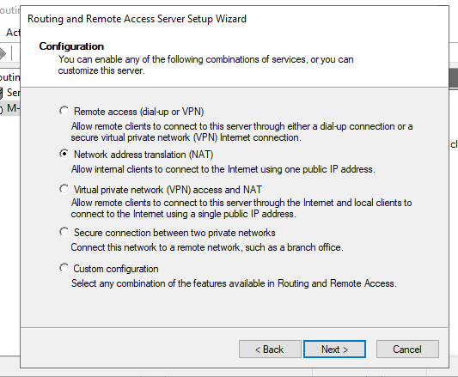

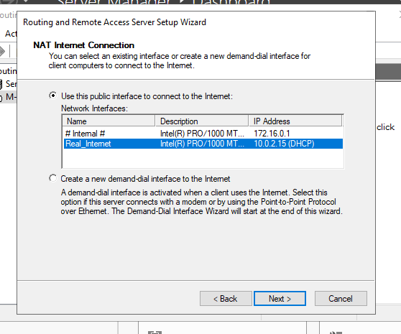

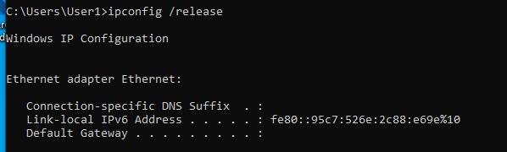
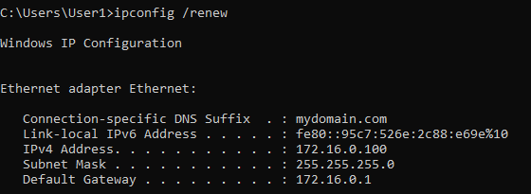
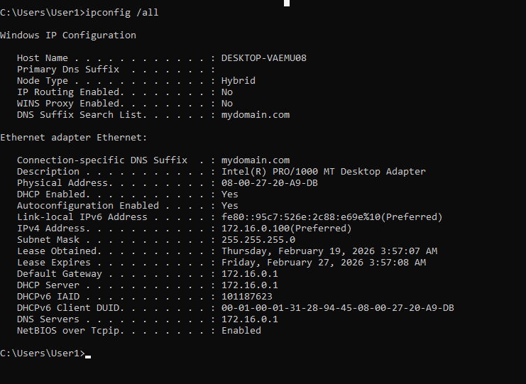
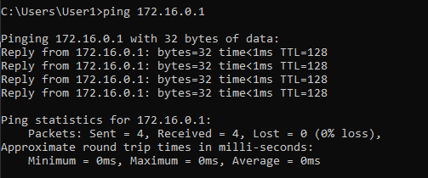

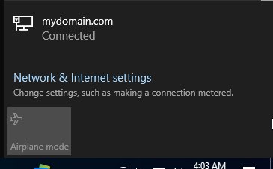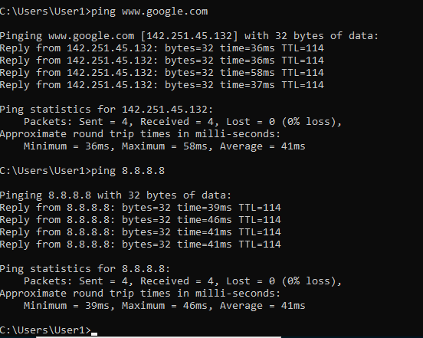

After several attempts to provide internet connectivity to the Client1 VM, it finally succeeded once I properly configured the Routing and Remote Access Service (RRAS) on the Domain Controller. Previously, the connection presumably failed because RRAS had either been partially configured or misconfigured, and the NAT routing between the DC’s internal network (172.16.0.x) and the host/NAT adapter (10.0.2.15) was not fully established. In this successful configuration, I disabled RRAS, which cleared the incorrect or incomplete routing and NAT settings, and then re-enabled it using the RRAS configuration. During the configuration, I explicitly set the public interface to the DC’s internet connected NIC (receiving a 10.0.2.15 address via DHCP from the host NAT) and the private interface to the DC’s internal NIC (172.16.0.1). By assigning the internal network as the private interface, Client1 correctly used the DC as its default gateway and DNS server, while the public interface handled NAT to forward traffic from the internal network to the internet. After renewing the IP on Client1 to refresh the DHCP lease, the VM was able to successfully reach external IP addresses and domain names. This outcome demonstrates the importance of correctly configuring RRAS NAT interfaces, clearly separating internal and public networks, and ensuring the routing service is fully restarted after configuration changes.

Integrating Client1 to DC

- Right now, Client1 is just on the same network as my Domain Controller.
- This means it can talk to the Domain Controller - (ping it, get IP/DNS) but it isn’t officially part of the domain yet.

Renaming Pc
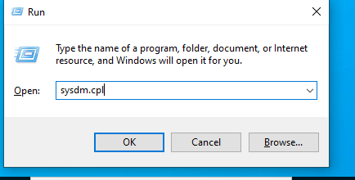
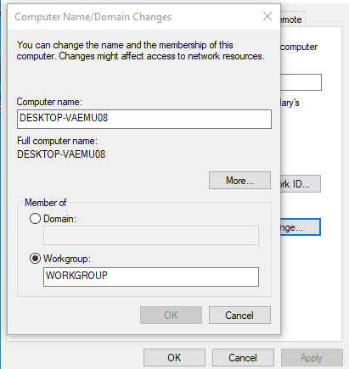
- Joining the domain is like registering the computer with Active Directory.
- After joining, AD knows about the computer.
- You can log in with AD users

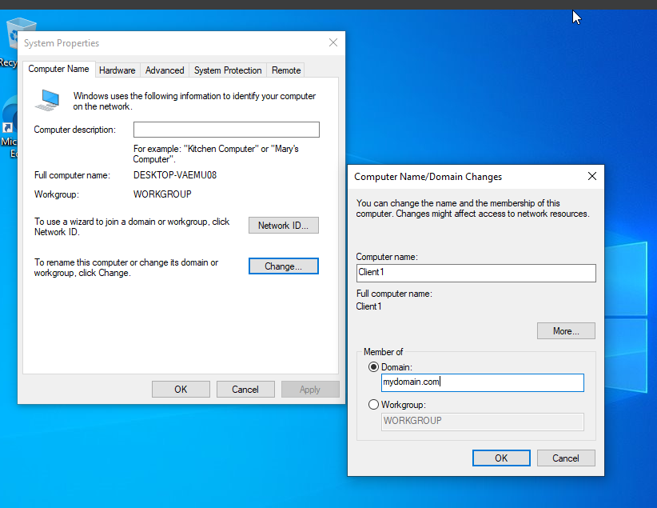

- This is joining the actual computer itself, not just the user. Im telling AD:
- this machine belongs in my domain
- The computer itself needs permission to join the domain
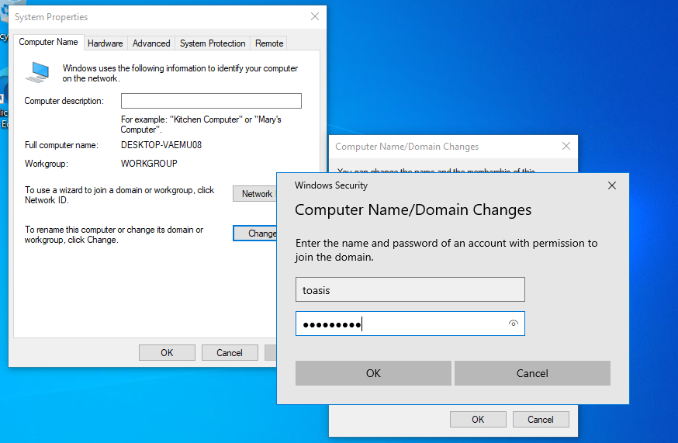
- It doesn’t have to be your personal account, it just has to have enough privileges to add the computer.

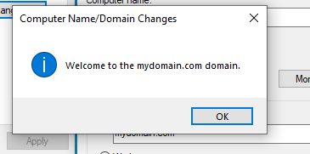

To fully integrate Client1 into the lab environment, I joined Client1 to the Active Directory hosted on the Domain Controller. Before this, Although the client was already on the internal 172.16.0.x network and able to communicate with the DC via ping, it , it was just talking to the Domain controller but wasn’t officially part of the domain

network connectivity alone didnt not make a machine a domain member. Joining the domain formalizes the relationship between the client and Active Directory, allowing it to authenticate AD users, receive Group Policy objects, and fully participate in domain services. Joining registers the computer with AD, allowing AD logins, group policies etc

Using sysdm.cpl, I updated the computer name for proper identification and added it to the domain using the necessary admin credentials. This step makes Client1 operates as a fully managed device within the lab,By completing the domain join its allowing me to test user logins, group policies, and other Active Directory functions

Now they are signed in to domain with this computer: Client1

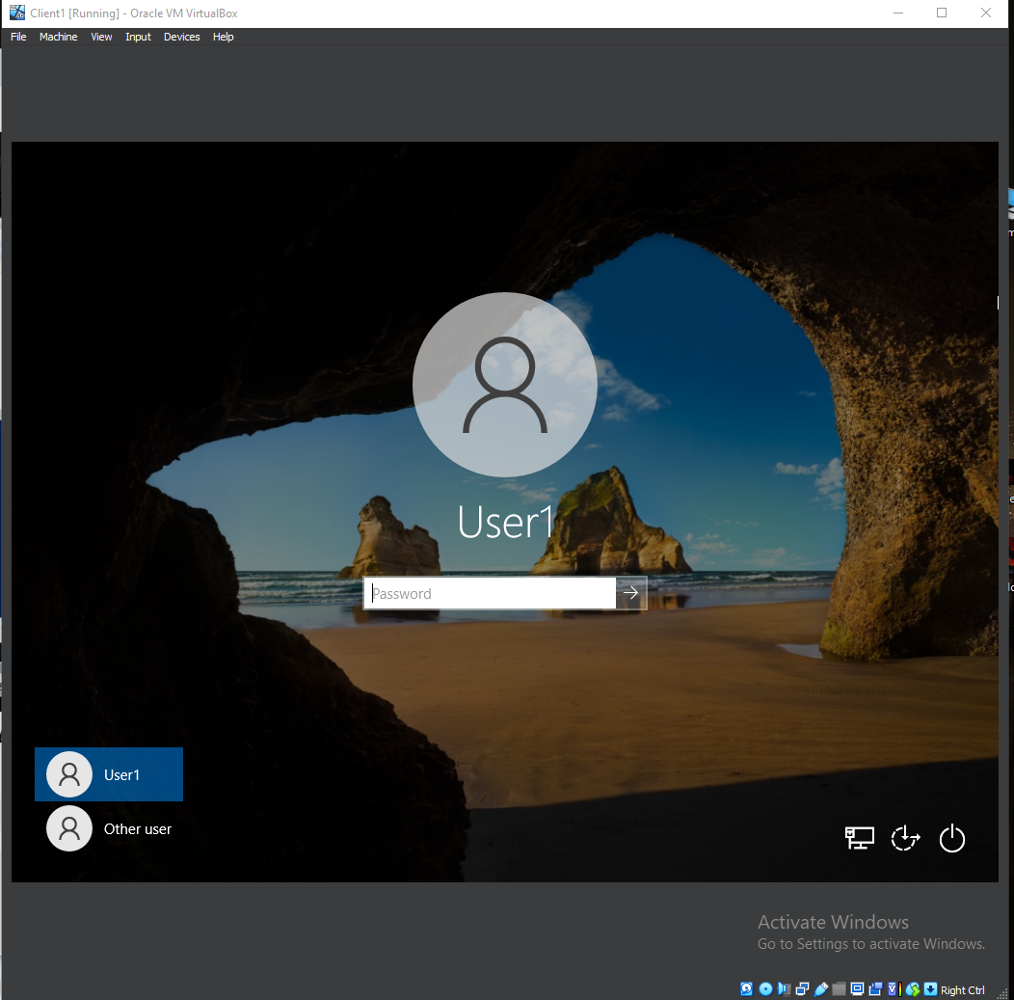

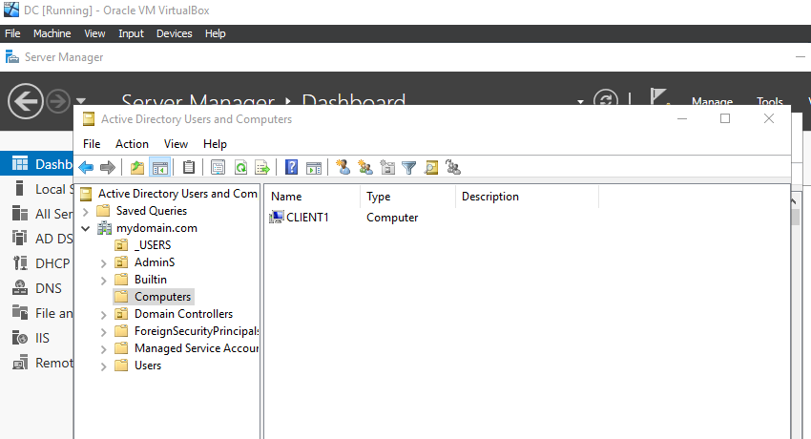

After client computer joined to domain; (above images) shows computer member of domain

And now it connects to domain any of the accounts the scripted created can now login

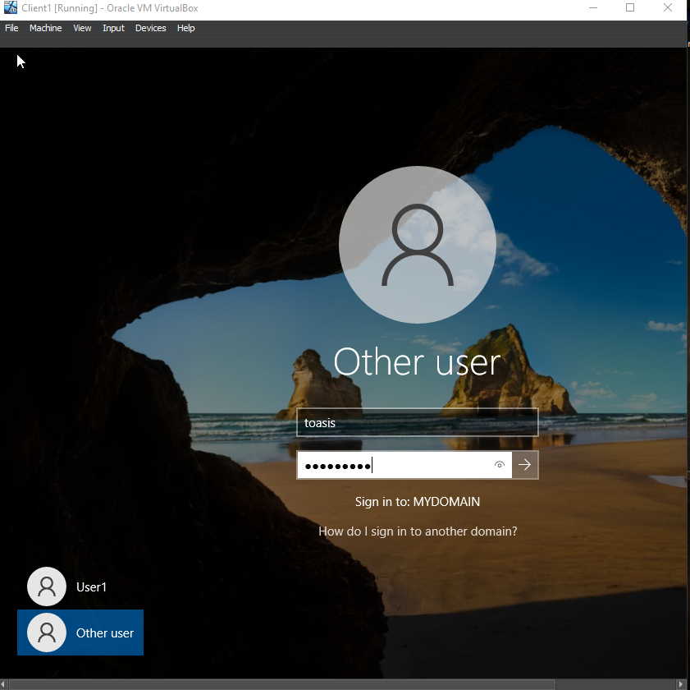
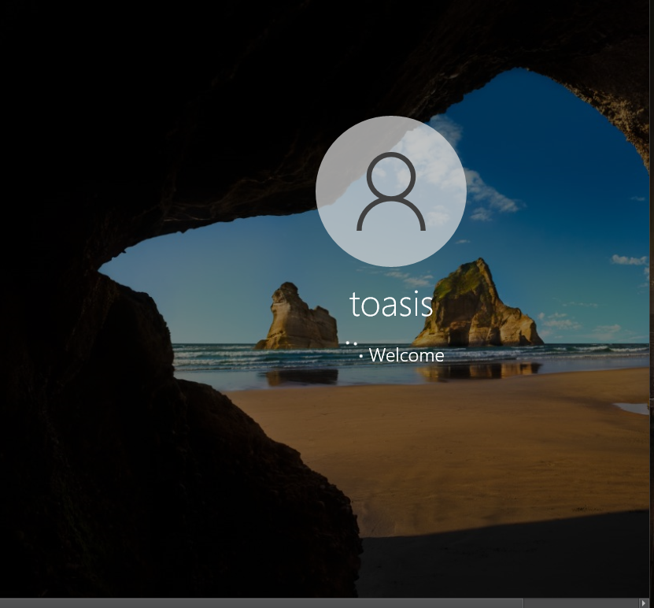

Client1 is joined to the Active Directory domain. The computer is registered with the DC, allowing me to log in with AD credentials and access domain resources

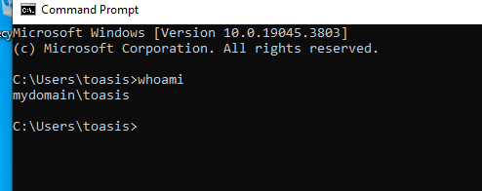

Simulation: There is a new employee at a company. The IT team adds my name to Active Directory (in my lab, the script created the account), and now my computer Client1, like my corporate laptop, is joined to the domain. Because the computer is registered, I can log in with my AD username and password(Company credentials), access domain resources, and have any policies or settings the company applies automatically. The computer had to connect to the Domain Controller over the network to register itself, but after that, it can even allow logins offline using cached credentials. This shows how domain membership works in a real world environment and demonstrates my understanding of enterprise Active Directory management

